Accessibility Collection Guide

Bag Books:
These are multi-sensory books for people with severe or profound and multiple learning disabilities.
Consisting of a few lines, the story is accompanied by some form of sensory element such as something to touch, smell, sound or physical interaction with the story teller.
Reservable to all libraries.
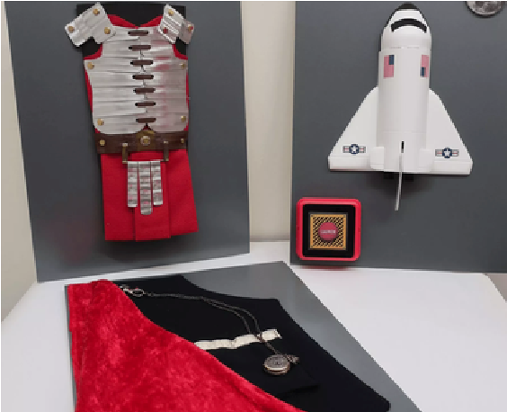

Braille Books:
We have a selection of children’s books in large print and braille. This includes board and picture books.
Available in Bath Central, Keynsham and Midsomer Norton and reservable to all libraries.
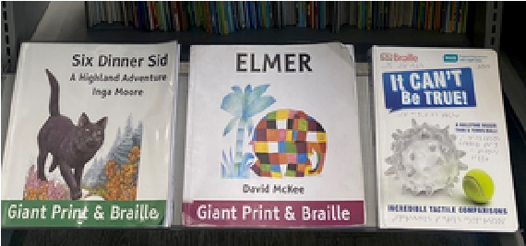

Story Sacks:
Story Sacks are a fun, interactive storytelling resource. They include props, activities and stories, and are designed to stimulate literacy and language skills.
They are particularly helpful in SEND Settings.
Reservable to all libraries.


Sweet Cherry Books:
Sweet Cherry books are accessible children’s stories. They include dyslexic friendly font, illustrations to support comprehension and a predictable format. Each book includes a QR code to access a free audiobook and a signed video of the story.
Available in Bath Central and reservable to all libraries.
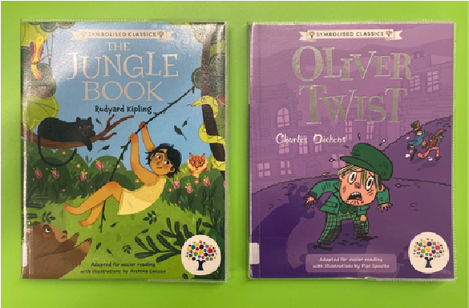

Dyslexia Friendly Books and Reading Rulers:
We have dyslexia-friendly books for Adults, Young Adults and Children. They use different paper colour, clear layouts, larger line spacing and wider margins to help readers follow the text more easily.
We also have a range of differently coloured dyslexia friendly reading rulers. They are useful to help reduce the harsh contrast of black text on white paper.
Available in Bath Central, Keynsham and Midsomer Norton libraries.
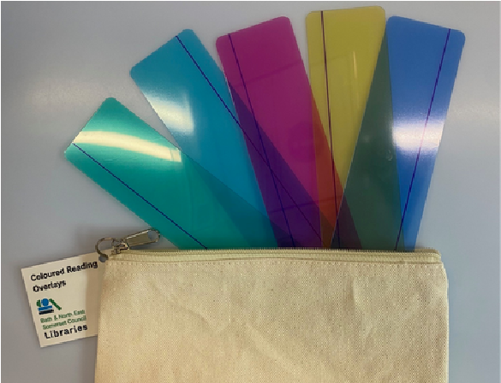

Read Along Audiobooks:
A read along audiobook is a spoken word CD and physical book of the same children’s story packaged together. This means you can listen to the story at the same time as following along with your eyes. These are useful to improve comprehension and pronunciation.
Available in Bath Central Library.
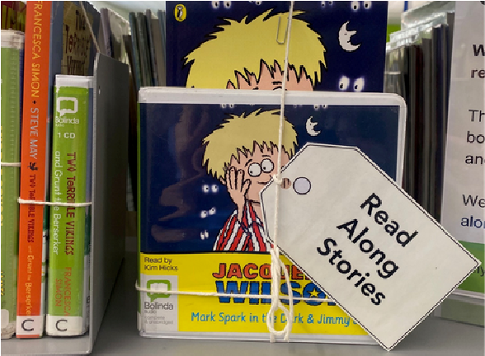

Sensory Explorer Bags:
The bags are free to use in our spaces, and all contain:
- a guide to the library
- sensory/fidget toy(s) and ear defenders
Available in Bath Housing, Welfare and Advice Services, Bath Central, Keynsham, Midsomer Norton and the Mobile libraries.
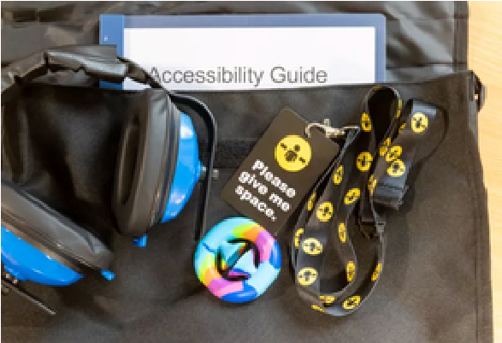

Books Beyond Words:
Each book contains word-free picture stories, enabling readers to tell their own stories using their own method of communication. Every story has been co-created with people with lived experience of learning disabilities.
Available in Bath Central library
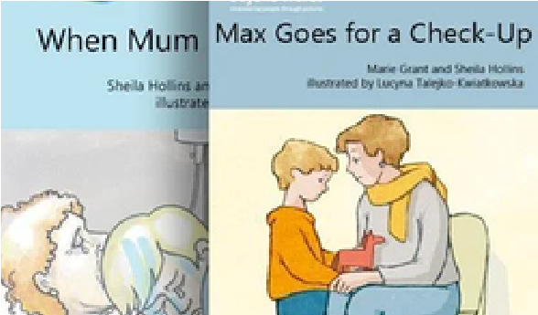

Audiobooks:
Our spoken word CD collections are available for adults, children and teens.
BorrowBox offers library members free access to eAudiobooks and eBooks. Both can be customised to improve accessibility.
Available in all our libraries.
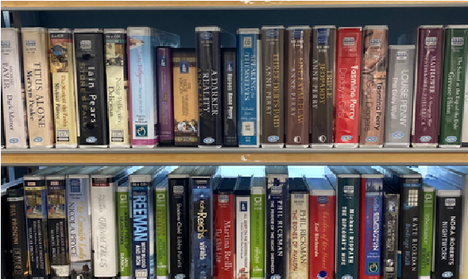

Braille Lego & Alphabet Tiles:
Each Lego Braille brick includes studs that correspond to numbers and letters in the braille code. They help children with visual impairment practice their skills while giving the whole family a way to play together.
Each double-sided Alphabet Tile features a raised Braille symbol paired with a clearly indented alphabet letter with upper case on one side and lower case on the other.
Available in Bath Central Library.
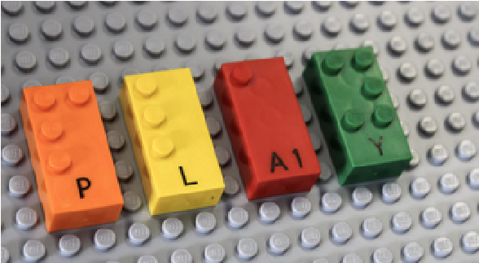

Adult Beginner Reads:
A collection of adult beginner readers, many of which have been written by adults who are themselves developing their literacy skills.
Available in Bath Central Library and reservable to all libraries.
