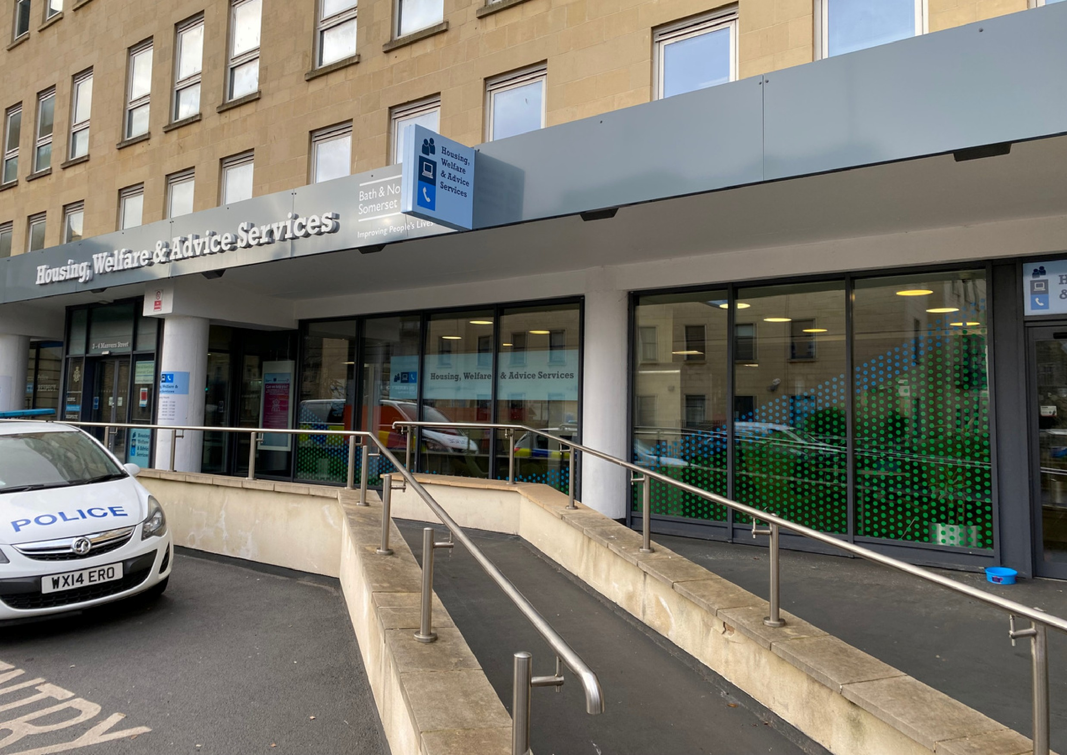

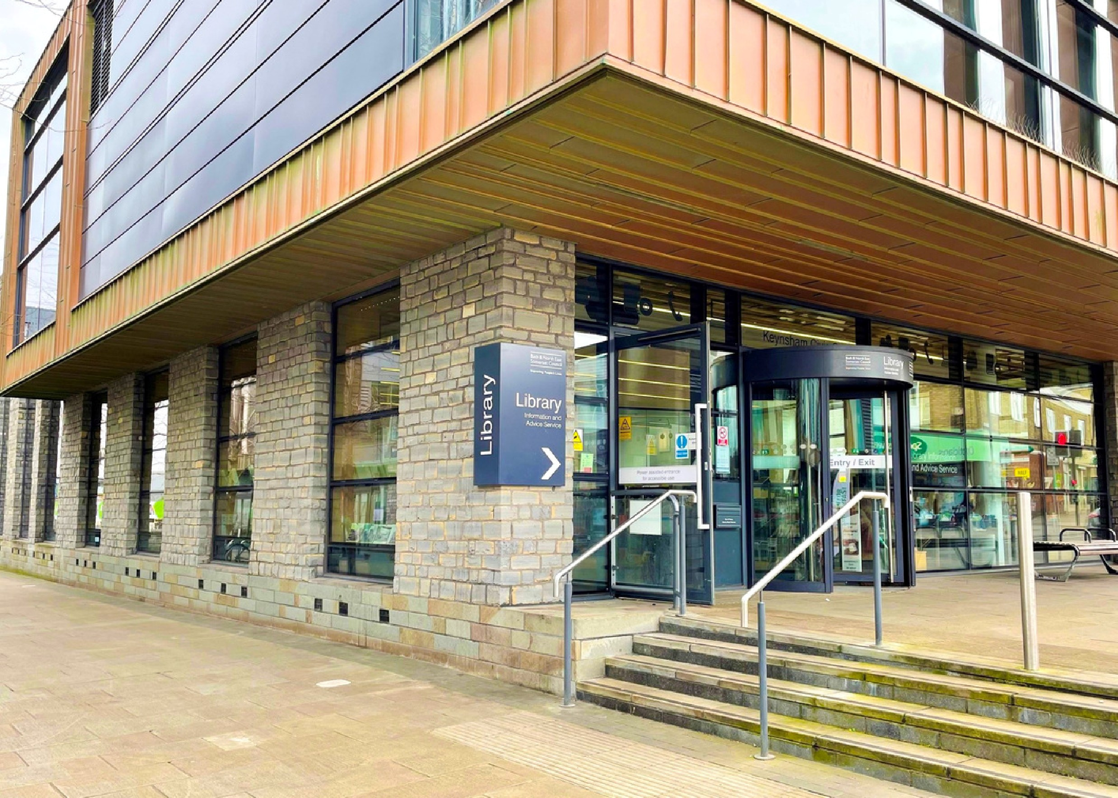
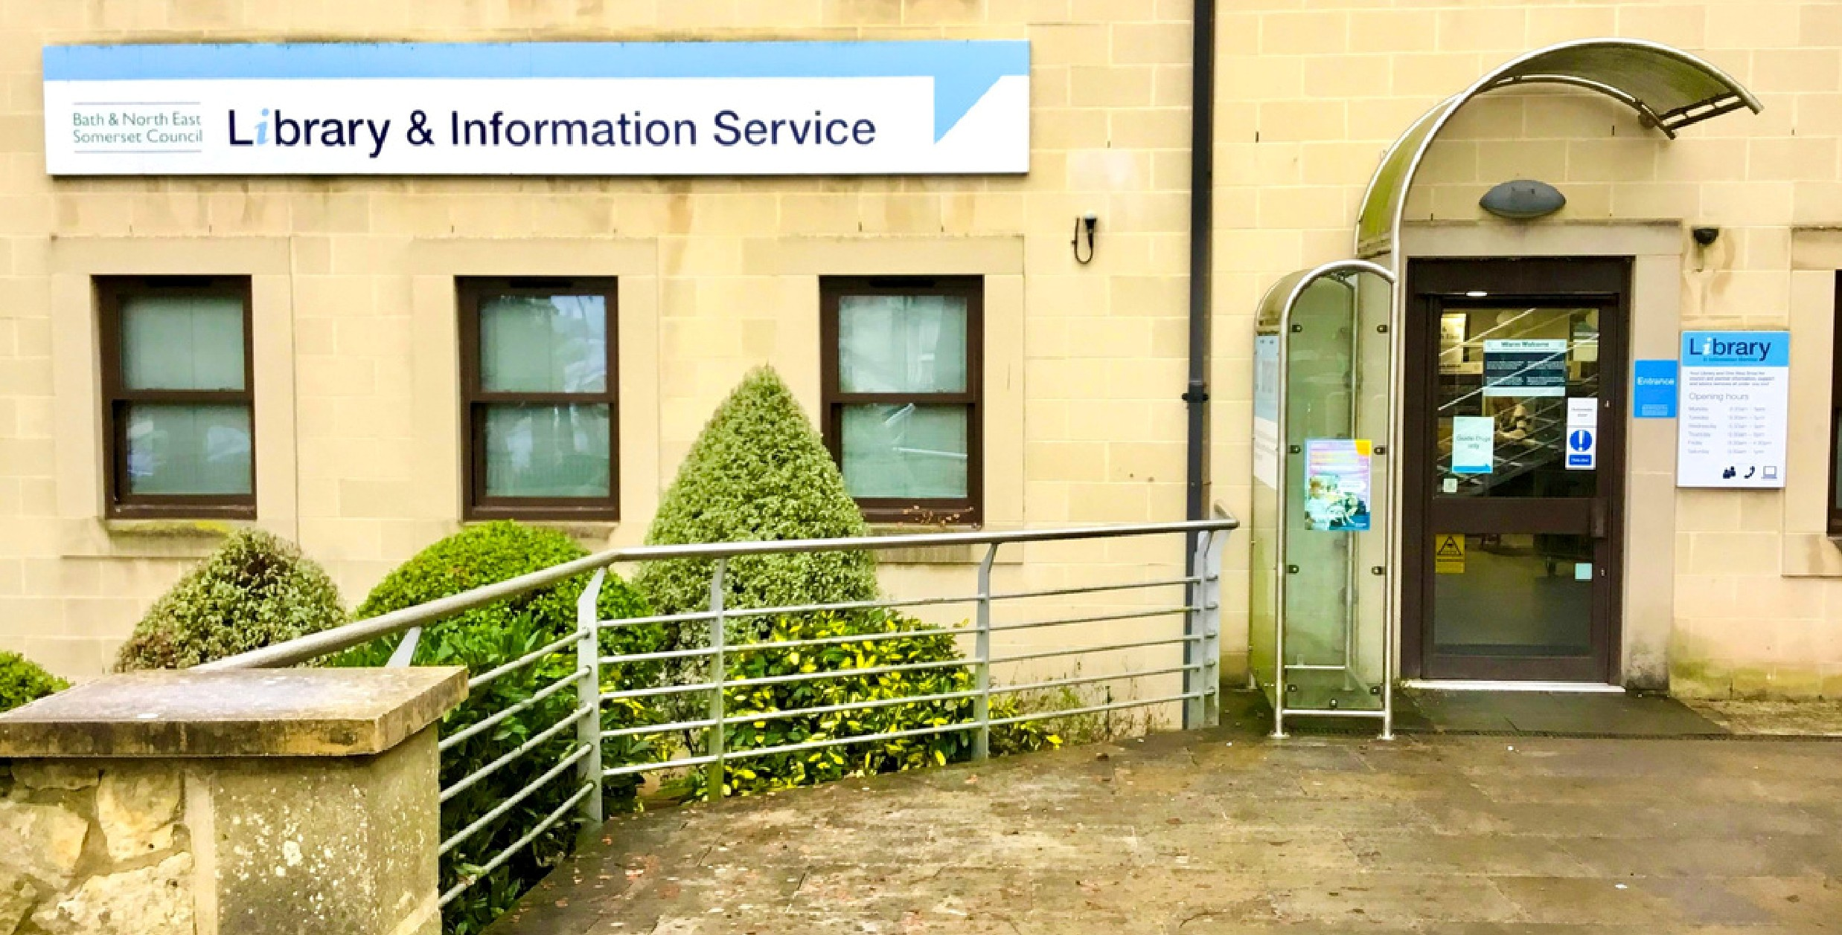

Keynsham Library
July 2026
Sensory Space
Guide

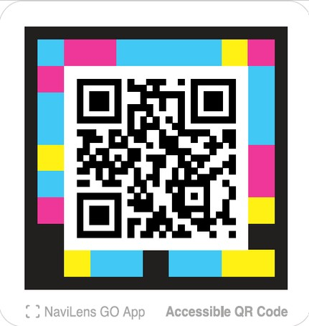
These productions were supported using public funding by Arts Council England. B&NES Libraries thank Libraries Connected and Arts Council England for their generous support.
Learn how to
find us and what
services and
facilities are
available when
you arrive.
Watch an introductory tour of this library

Video guides

Watch these videos on YouTube and select the CC button to turn on Closed Captions. Follow along using the transcript.
Bath &




Sensory space at Keynsham Library

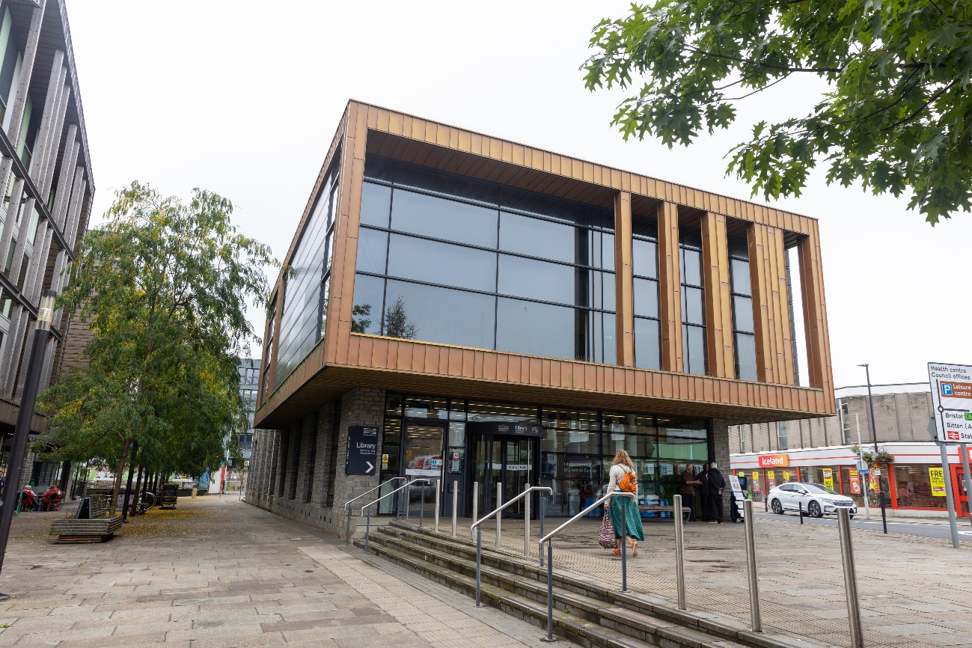

Visiting the library to use the sensory space 4
About the sensory space 5
What is inside the room? 6
Accessing more information 11

Visiting the library to use the sensory space

I am going to Keynsham Library to visit the sensory space.

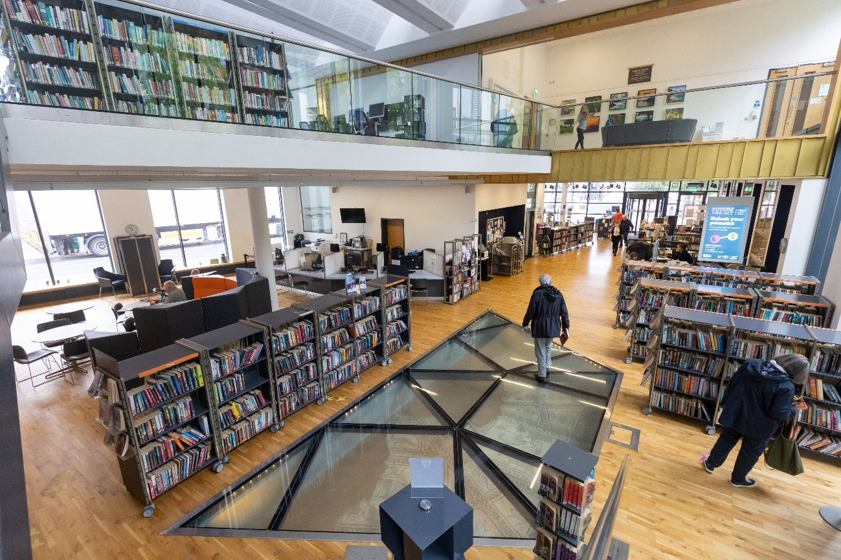

The Sensory Space is located at the back of Library. If I have booked a session through Eventbrite, or would like to use the room, I should speak to a member of staff.

Bookable sessions last 1.5 hours and start at:

- 10am
- 12pm
- 2pm

There is also a drop-in session from 3.30pm to 4.30pm. No booking is required for this session, and spaces are available on a first-come, first-served basis.

About the sensory space

I can tell someone at the information desk that I have arrived. They will show me where the Sensory Space is.


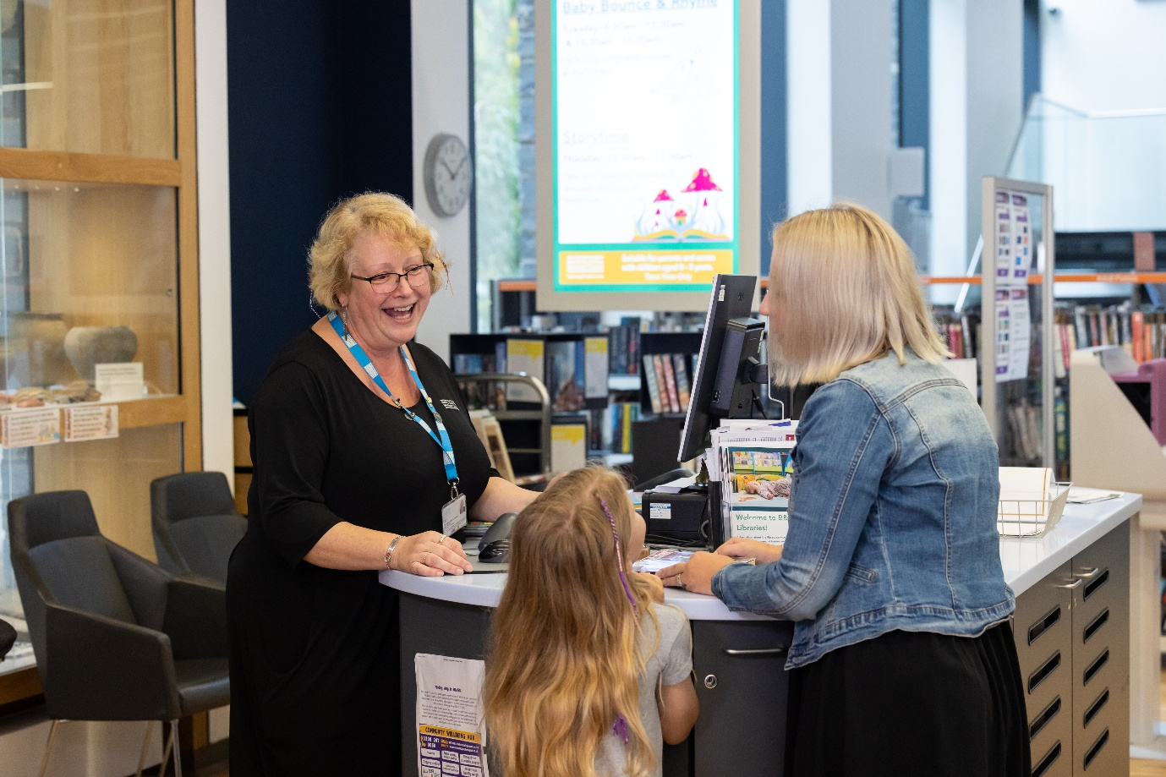

The sensory space is a room downstairs beyond the cafe area of the library.
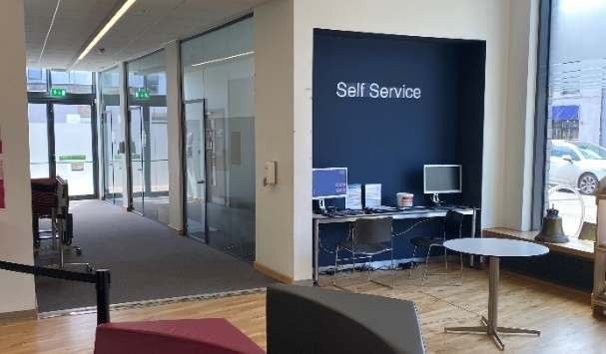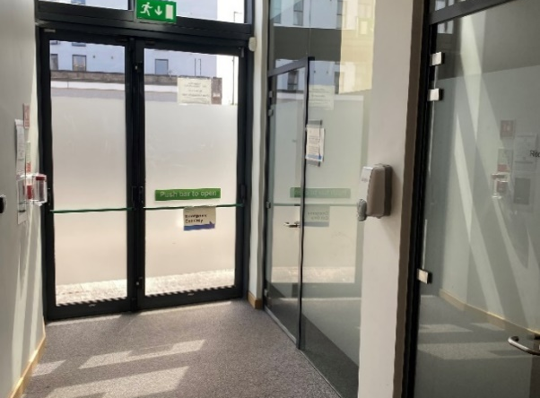

What is inside the room?

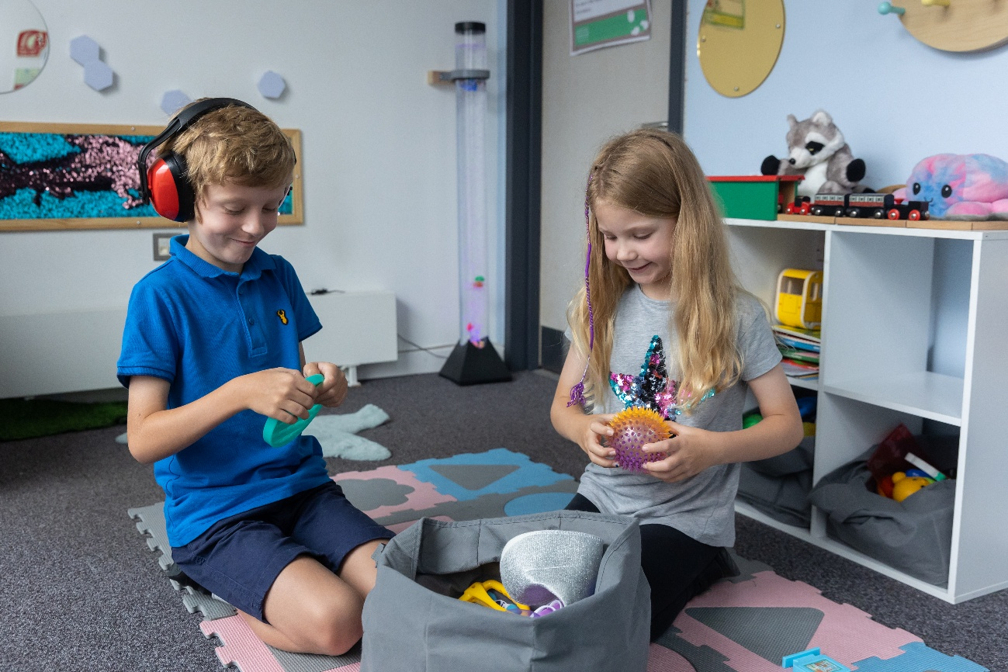

There is a comfy bean bag and rug with cushions where I can sit.

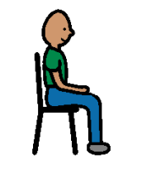

There is also a black out tent.

There is a comfy chair to sit on. There are baskets of things to touch, feel and play with and there are some noisy items too. 

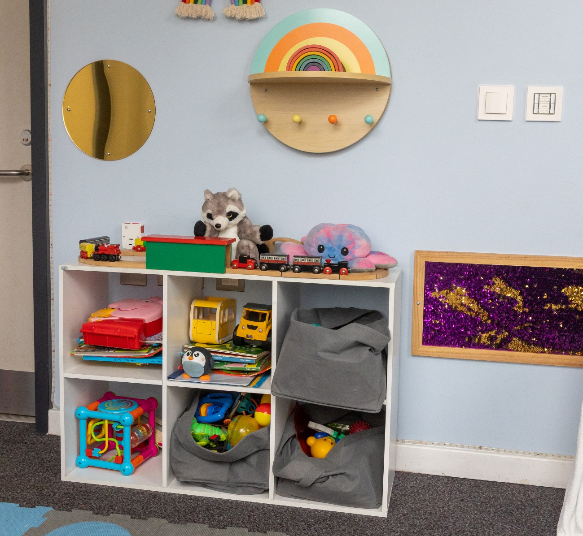

There is sensory lighting including a bubble light. If it is not switched on, I can ask someone in the library to help.

When my session is over, it will be someone else’s turn. When I leave, I should leave the room as I found it.

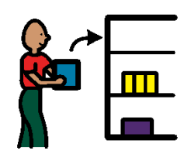

I can visit the library to look at books or borrow them if I am a member.
If I am not a member, I can ask about joining.
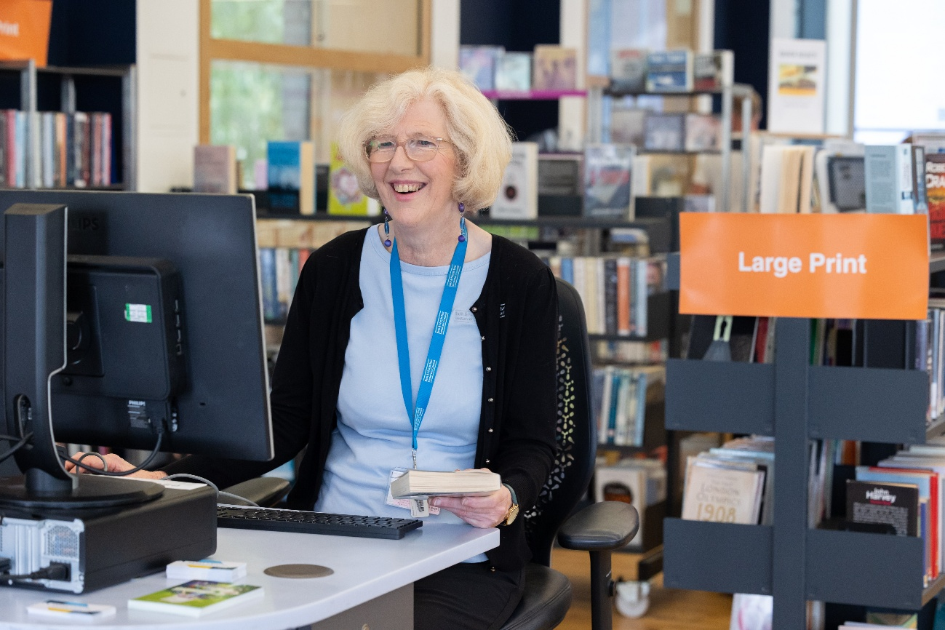
I can borrow a Sensory Explorer Bag to use in the library from the desk. This has ear defenders, a guide to the library and fidget toys in and more.
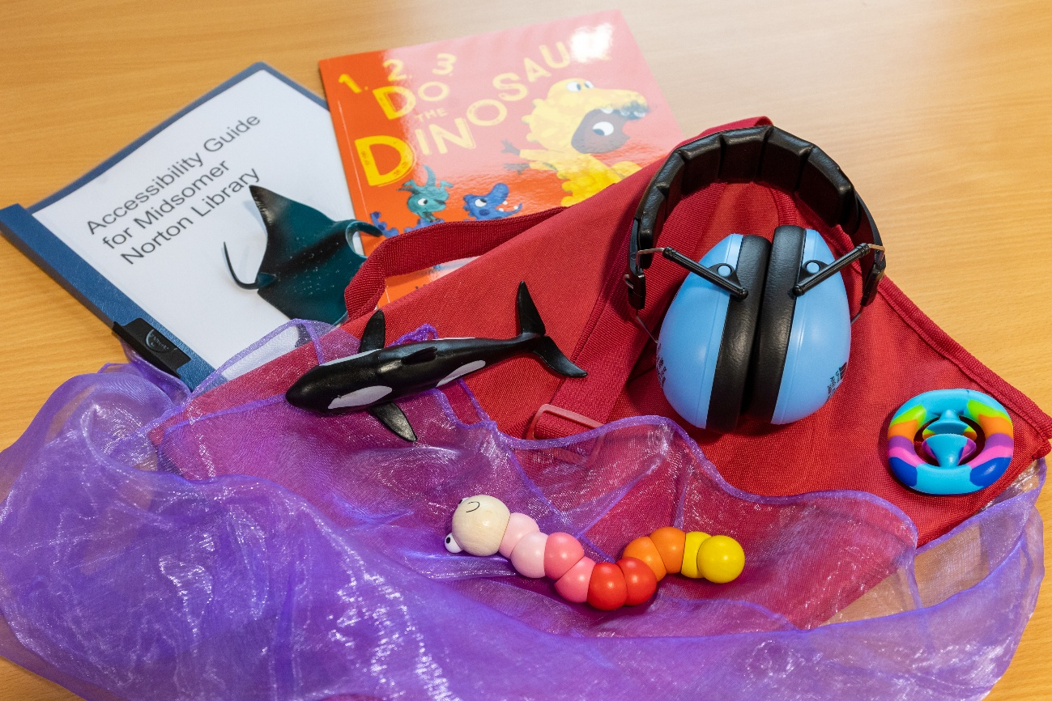
I can ask about resources to borrow like Story Sacks or Bag Books which make storytelling fun and interactive.
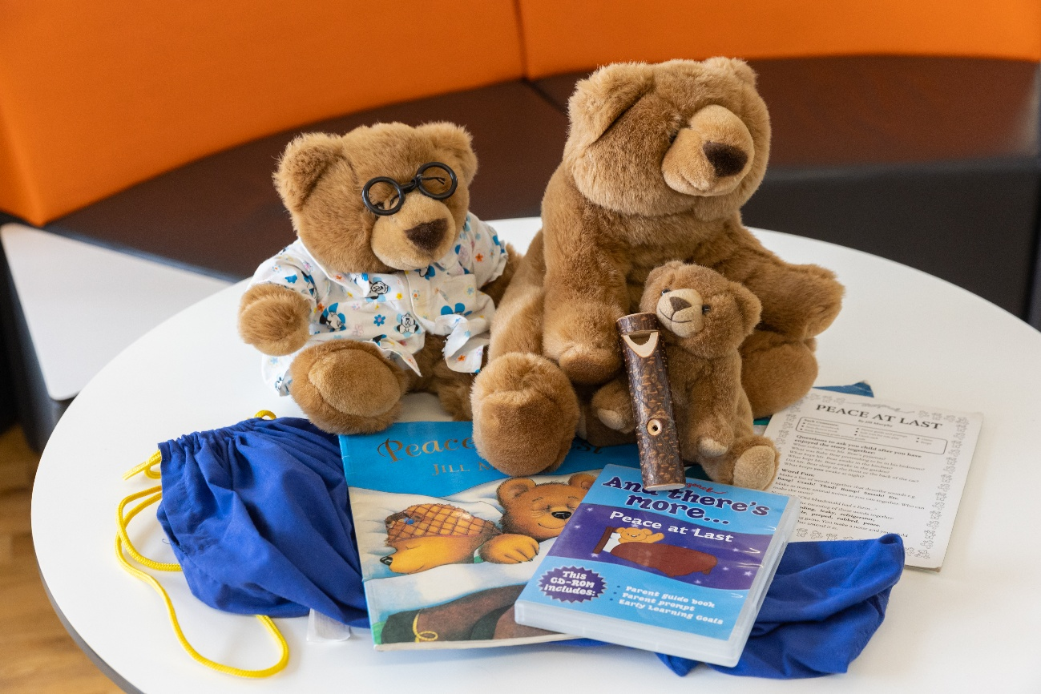
In the library, there are children’s and young adult sections and books for parents and carers.

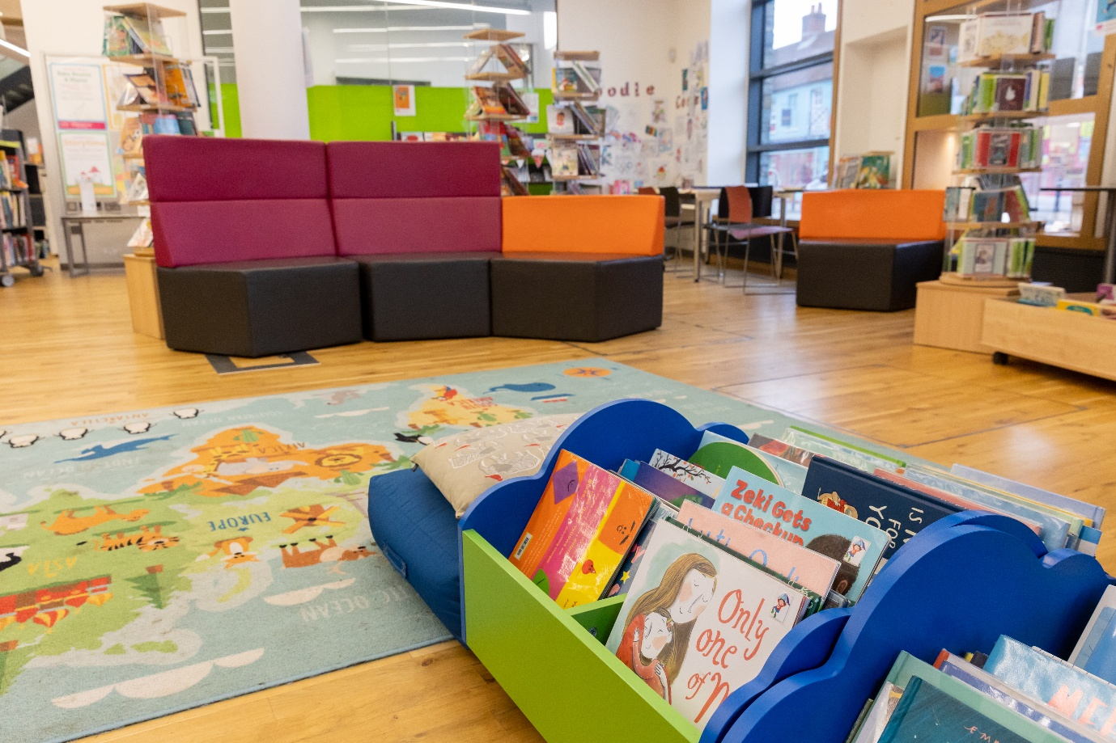

I can also ask about Book Trust material which can be gifted to young children with additional needs.

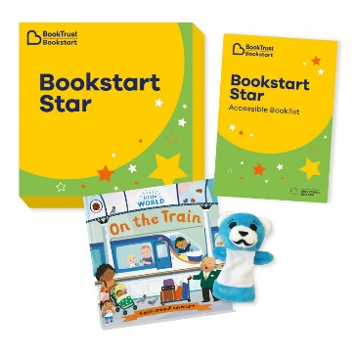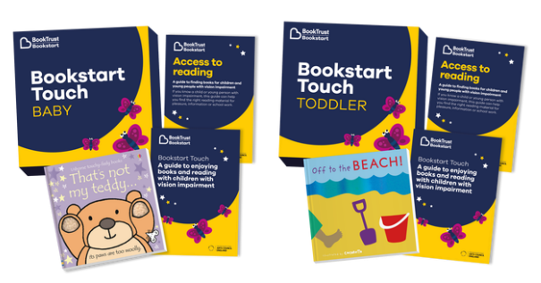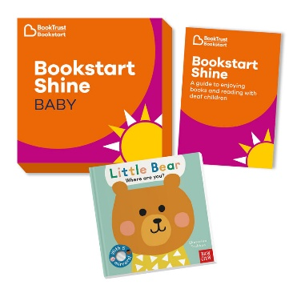

Accessing more information

I can visit the Virtual Library online to find out about events and special resources on the Access For All page: https://baneslibraries.co.uk/about-us/access-for-all/.

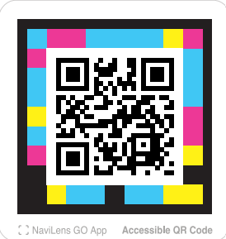

Follow this QR code to visit the Virtual Library.

