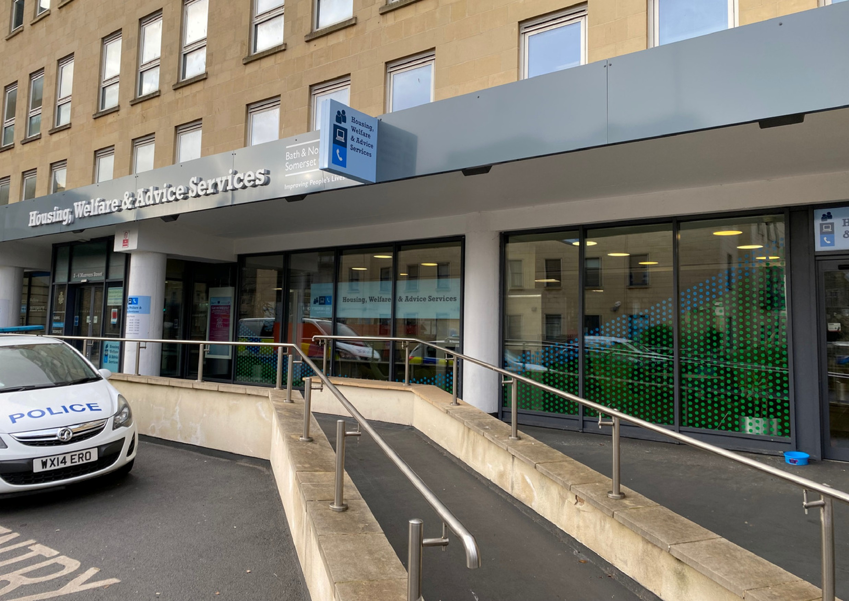

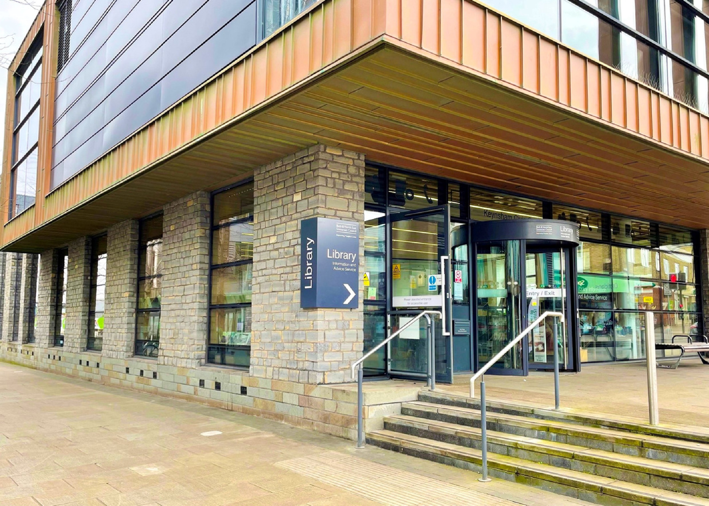
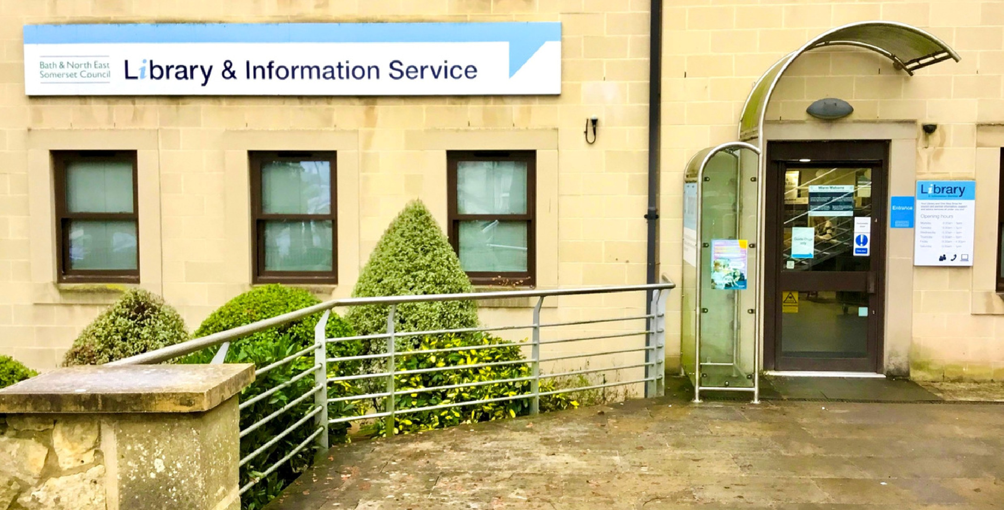

Bath Central Library
July 2026
Sensory Space
Guide

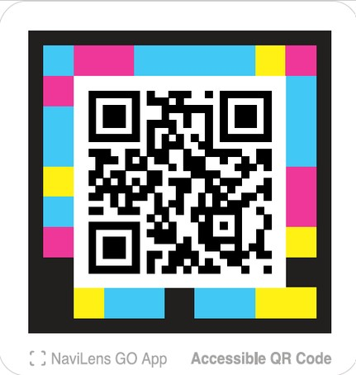
These productions were supported using public funding by Arts Council England. B&NES Libraries thank Libraries Connected and Arts Council England for their generous support.
Learn how to
find us and what
services and
facilities are
available when
you arrive.
Watch an introductory tour of this library

Video guides

Watch these videos on YouTube and select the CC button to turn on Closed Captions. Follow along using the transcript.
Bath &




Sensory space at Bath Central Library

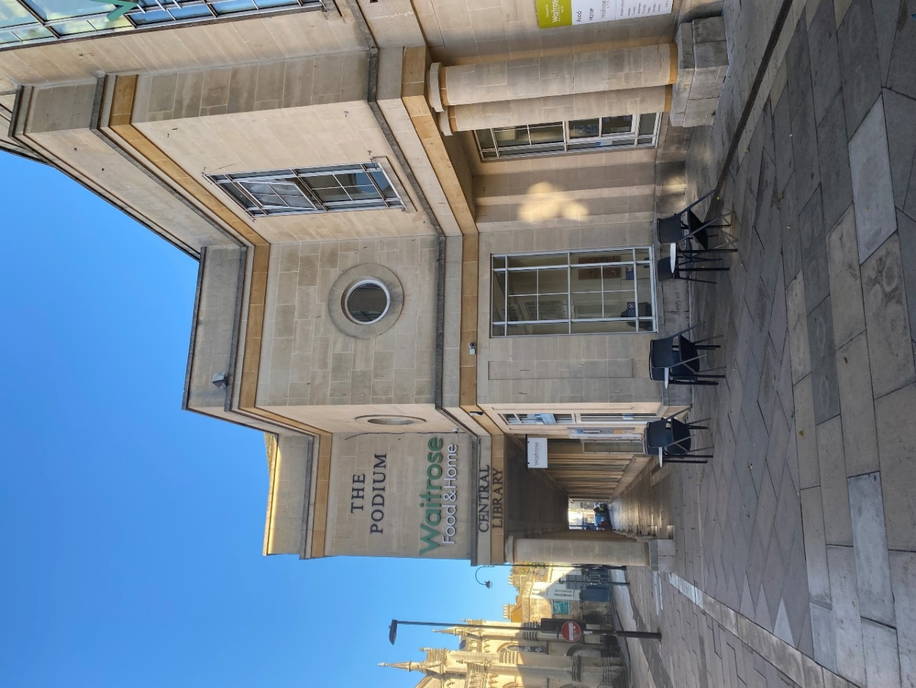

Visiting the library to use the sensory space 4
About the sensory space 5
What is inside the room? 6
Accessing more information 10

Visiting the library to use the sensory space

I am going to Bath Central Library to visit the sensory space.

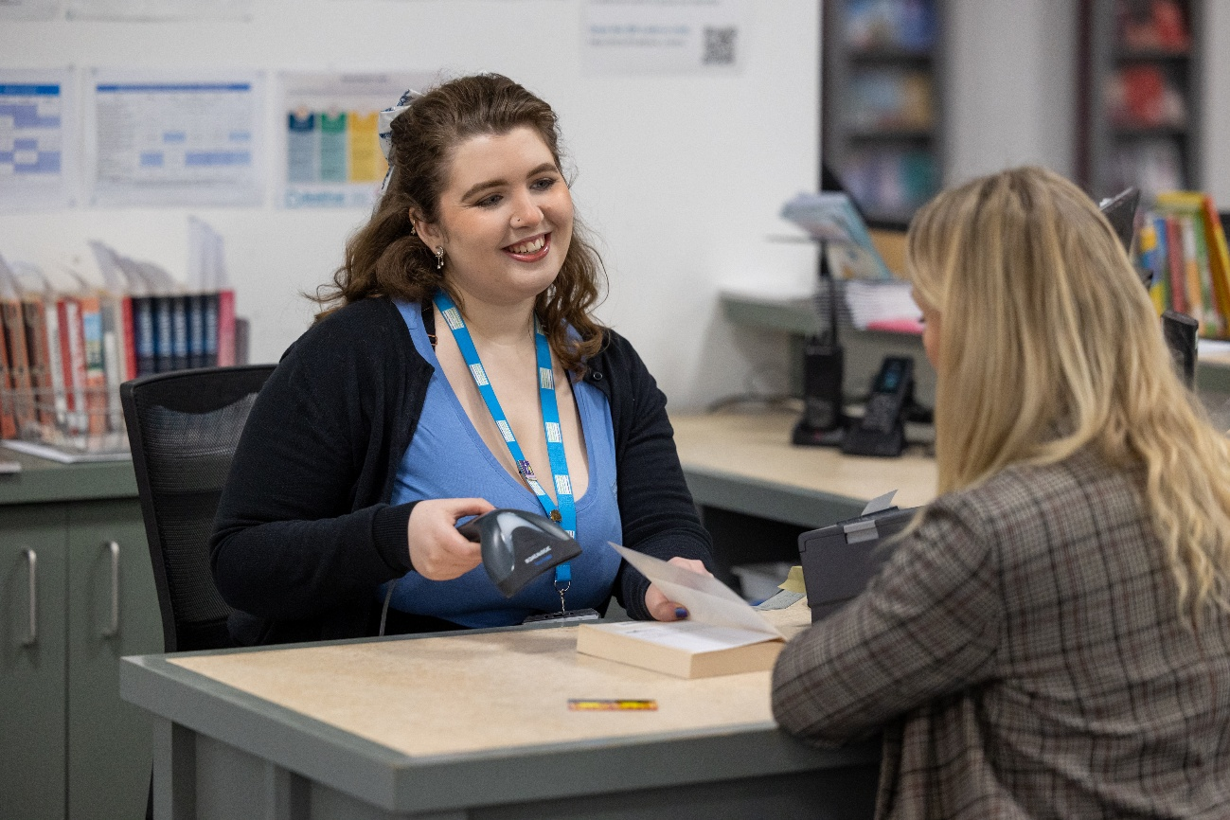


There are people who work at the library who I can talk to. They will be wearing lanyards around their necks to show they work for the Council.

About the sensory space

The Sensory Space is located at the back of the Children’s Library. To reach it, I need to go through the Children’s Library area.

If I have booked a session through Eventbrite, or would like to use the room, I should speak to a member of staff.

Bookable sessions last 1.5 hours and start at:
- 10am
- 12pm
- 2pm

There is also a drop-in session from 3.30pm to 4.30pm. No booking is required for this session, and spaces are available on a first-come, first-served basis.

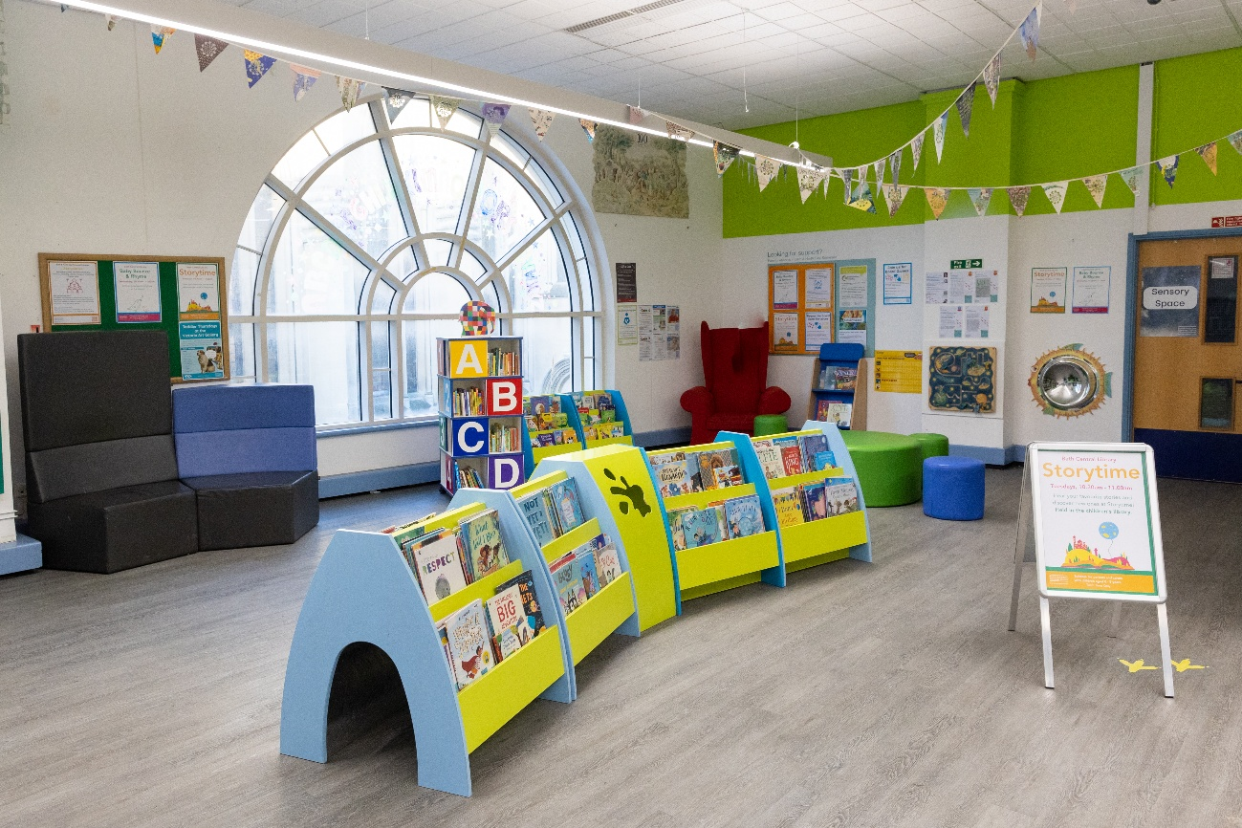

What is inside the room?

I can sit on bean bags, cushions on the rug, or a comfy chair. I can also look at books and use a weighted lap pad.

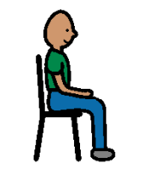
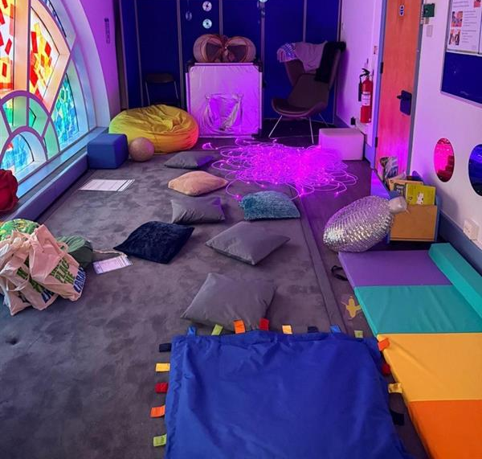
There is sensory lighting in the room. If it is not on, ask a member of library staff to help.
There is a blackout den and soft mats and items that I can touch, feel and play with.
.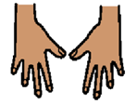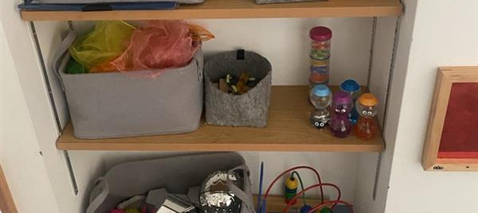
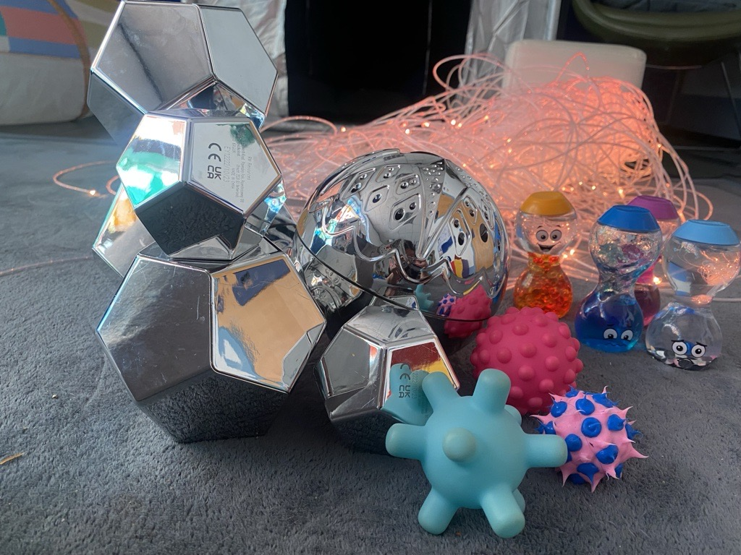
When my session is over, it will be someone else’s turn. When I leave, I should leave the room as I found it.

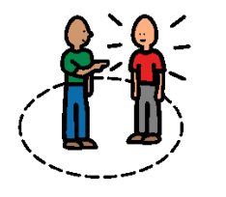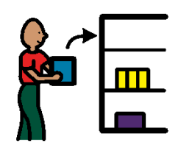

I can visit the library to look at books or borrow them if I am a member.
If I am not a member, I can ask at the library desk about joining.
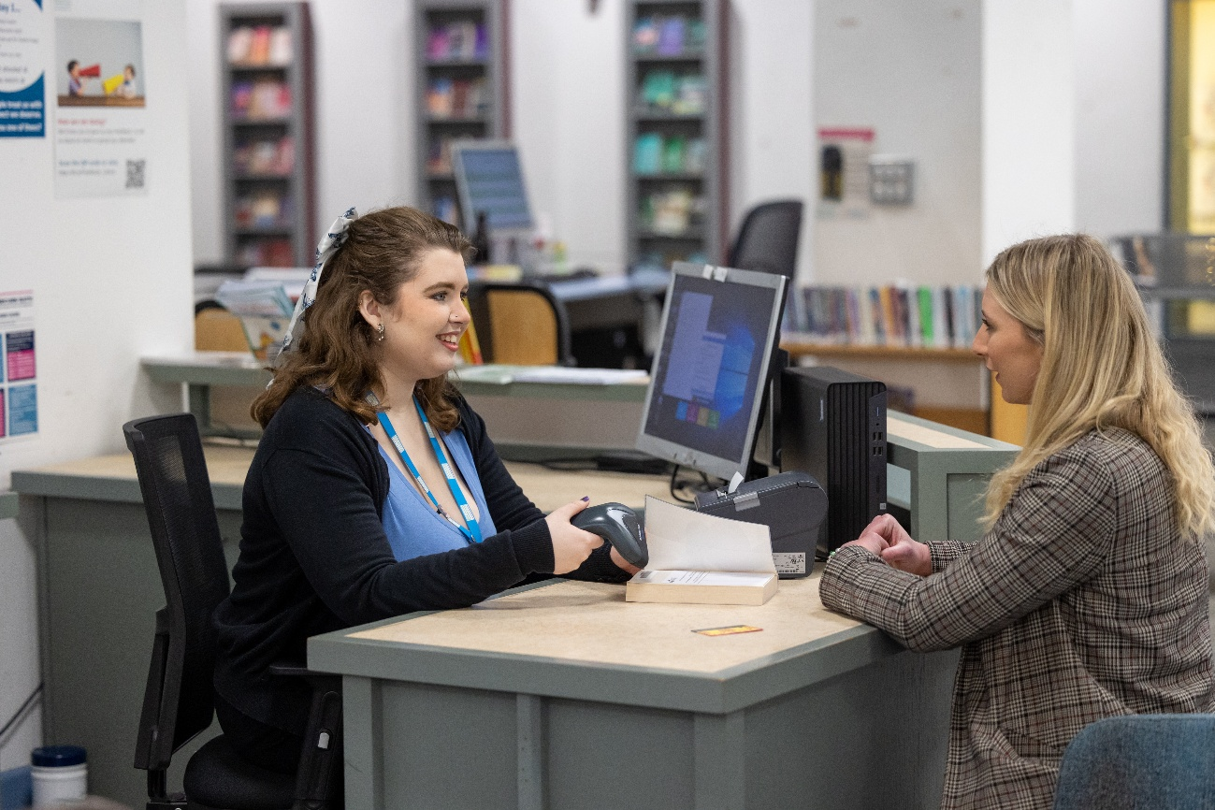
I can borrow a Sensory Explorer Bag to use in the library from the library desk. This has ear defenders, a guide to the library and fidget toys in and more.
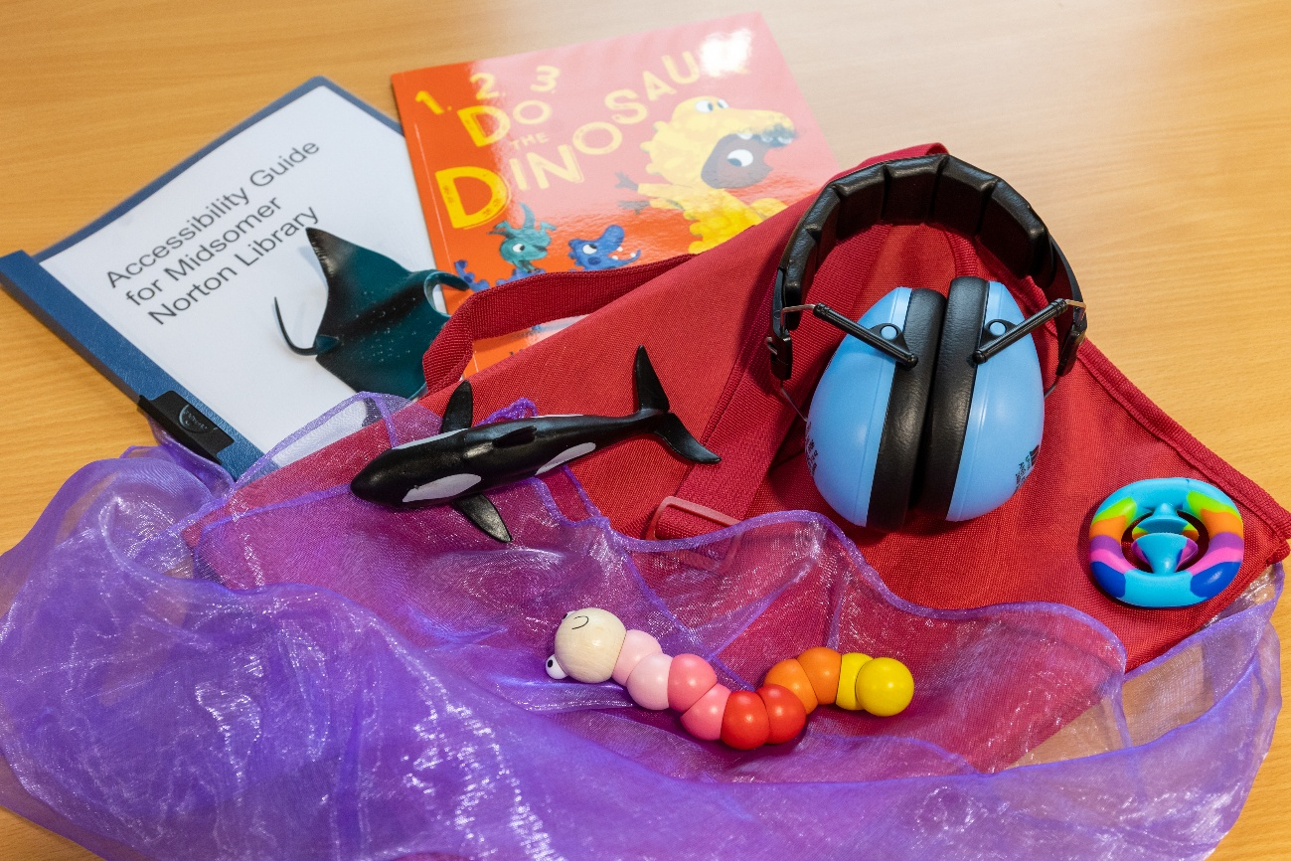

I can speak to staff about some of the available resources to borrow like Story Sacks or Bag Books which make storytelling fun and interactive. There is an Accessible Library Resources Shelf. 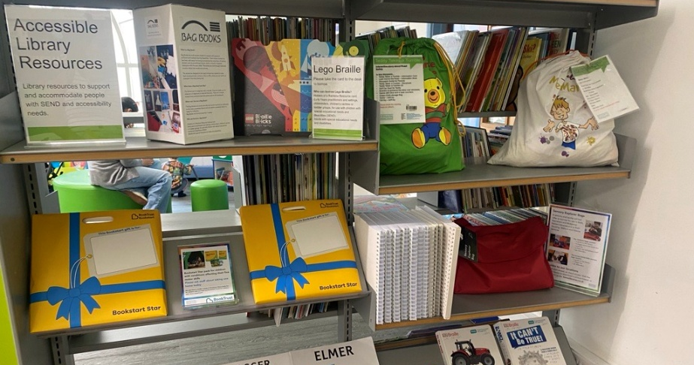
I can also ask about Book Trust material which can be gifted to young children with additional needs.
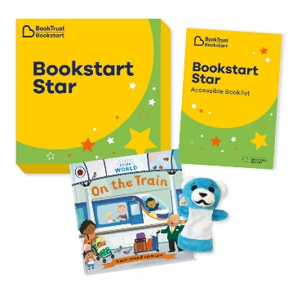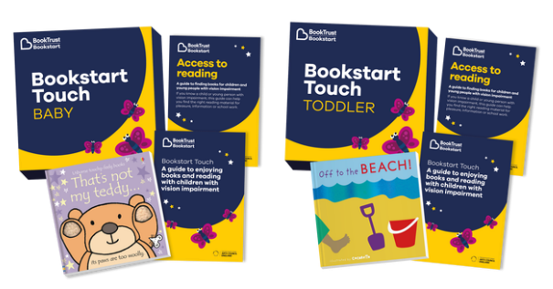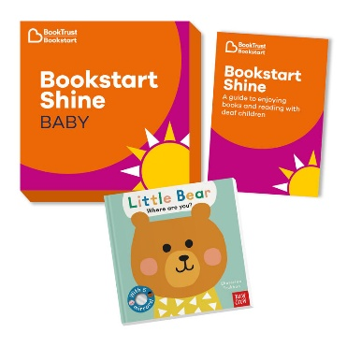

Accessing more information

I can visit the Virtual Library online to find out about events and special resources on the Access For All page: https://baneslibraries.co.uk/about-us/access-for-all/.

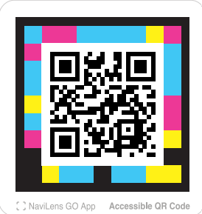

Follow this QR code to visit the Virtual Library.

