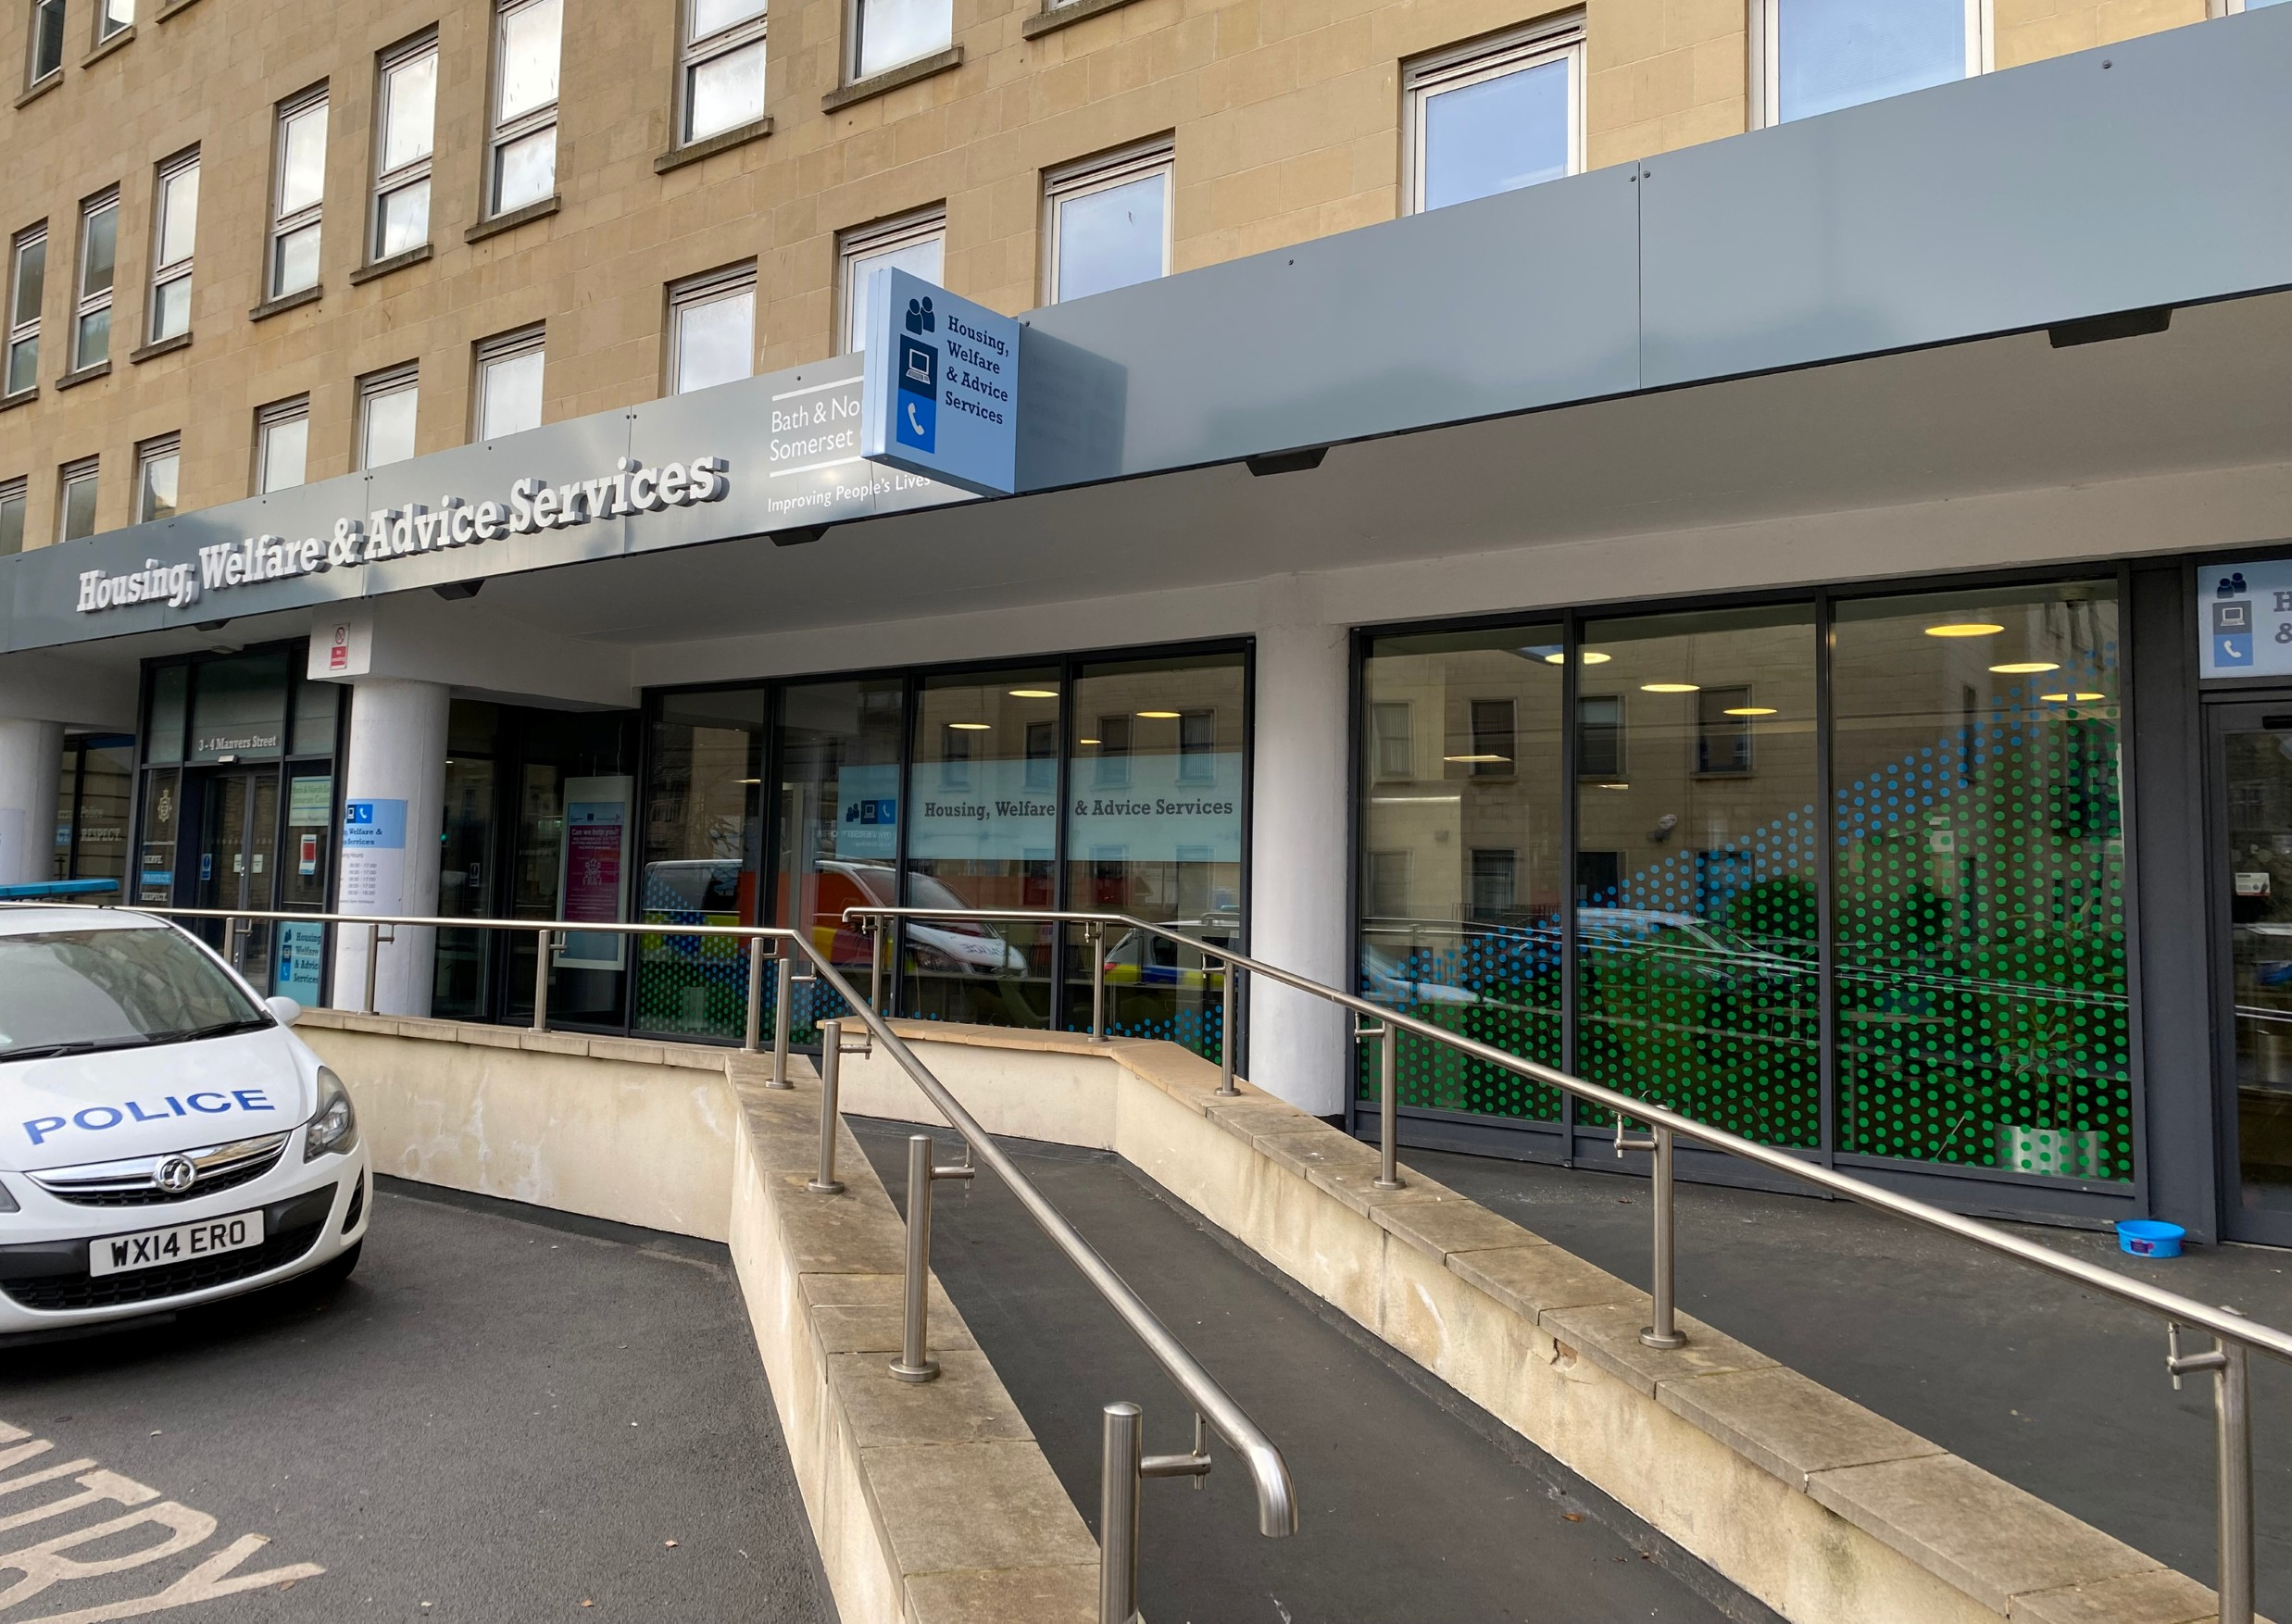
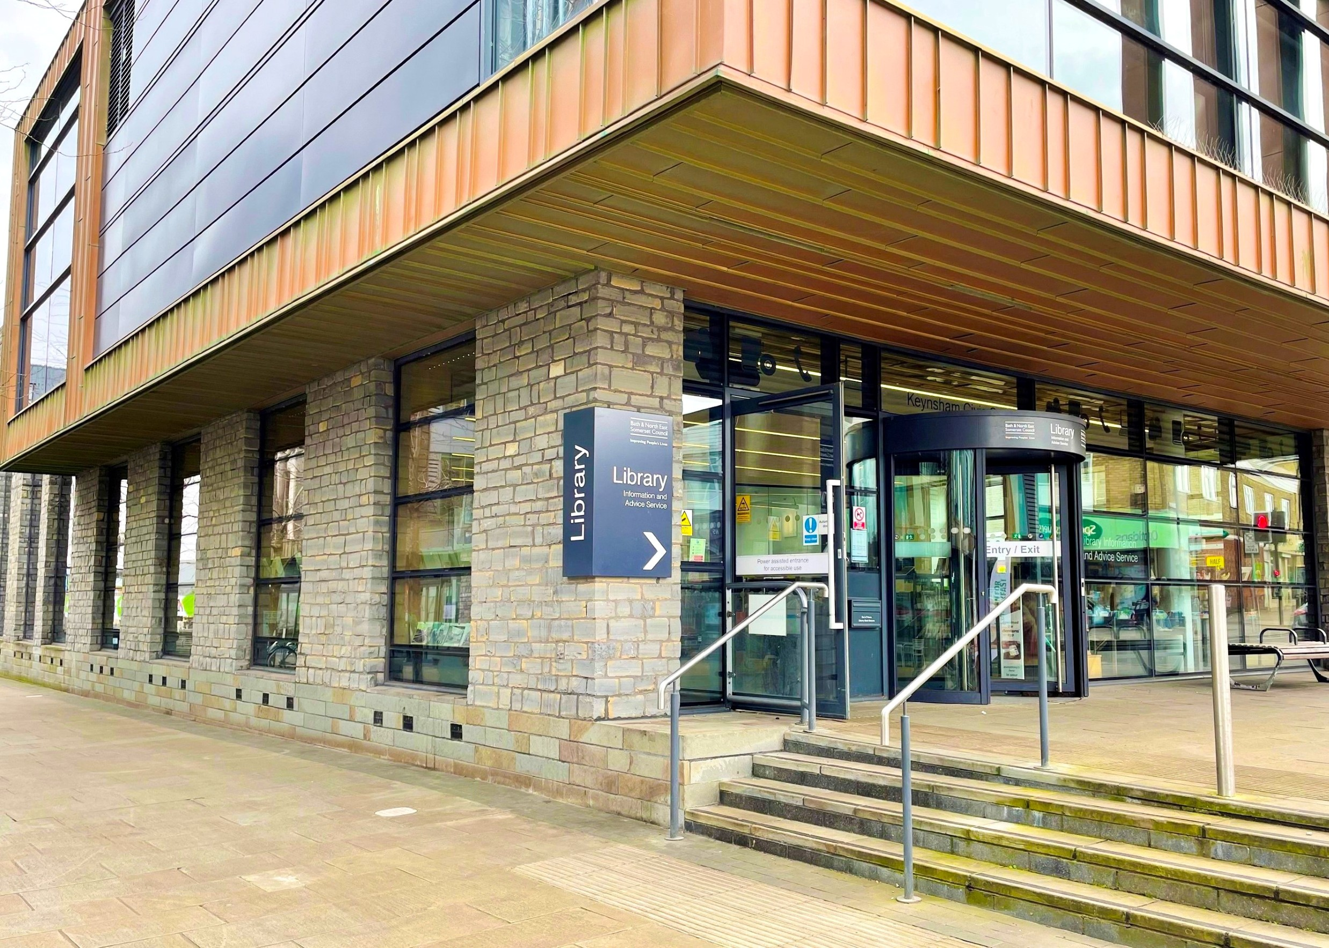
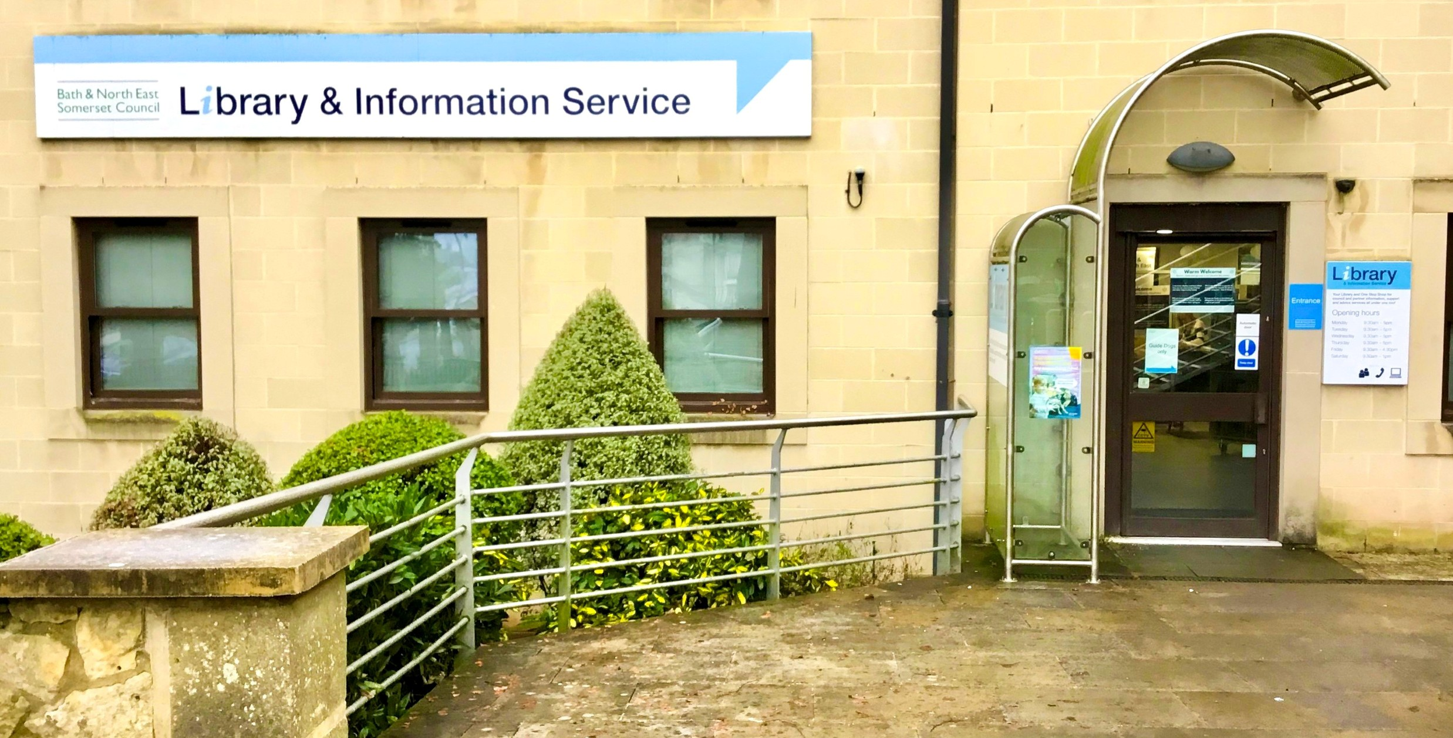

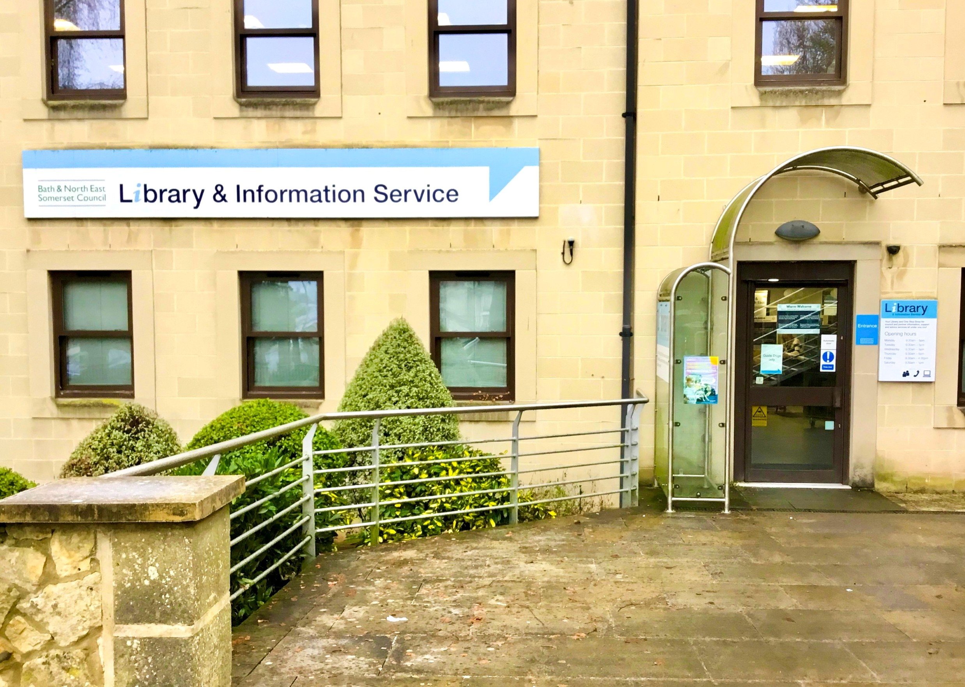
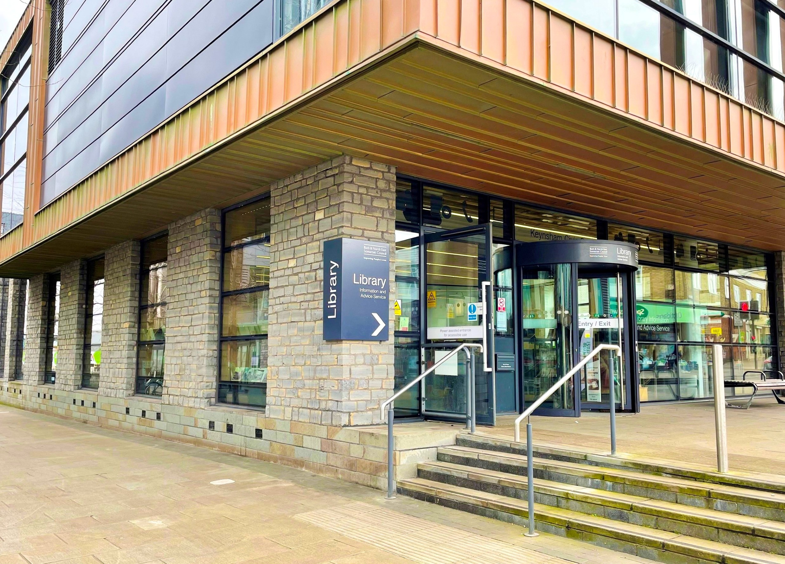
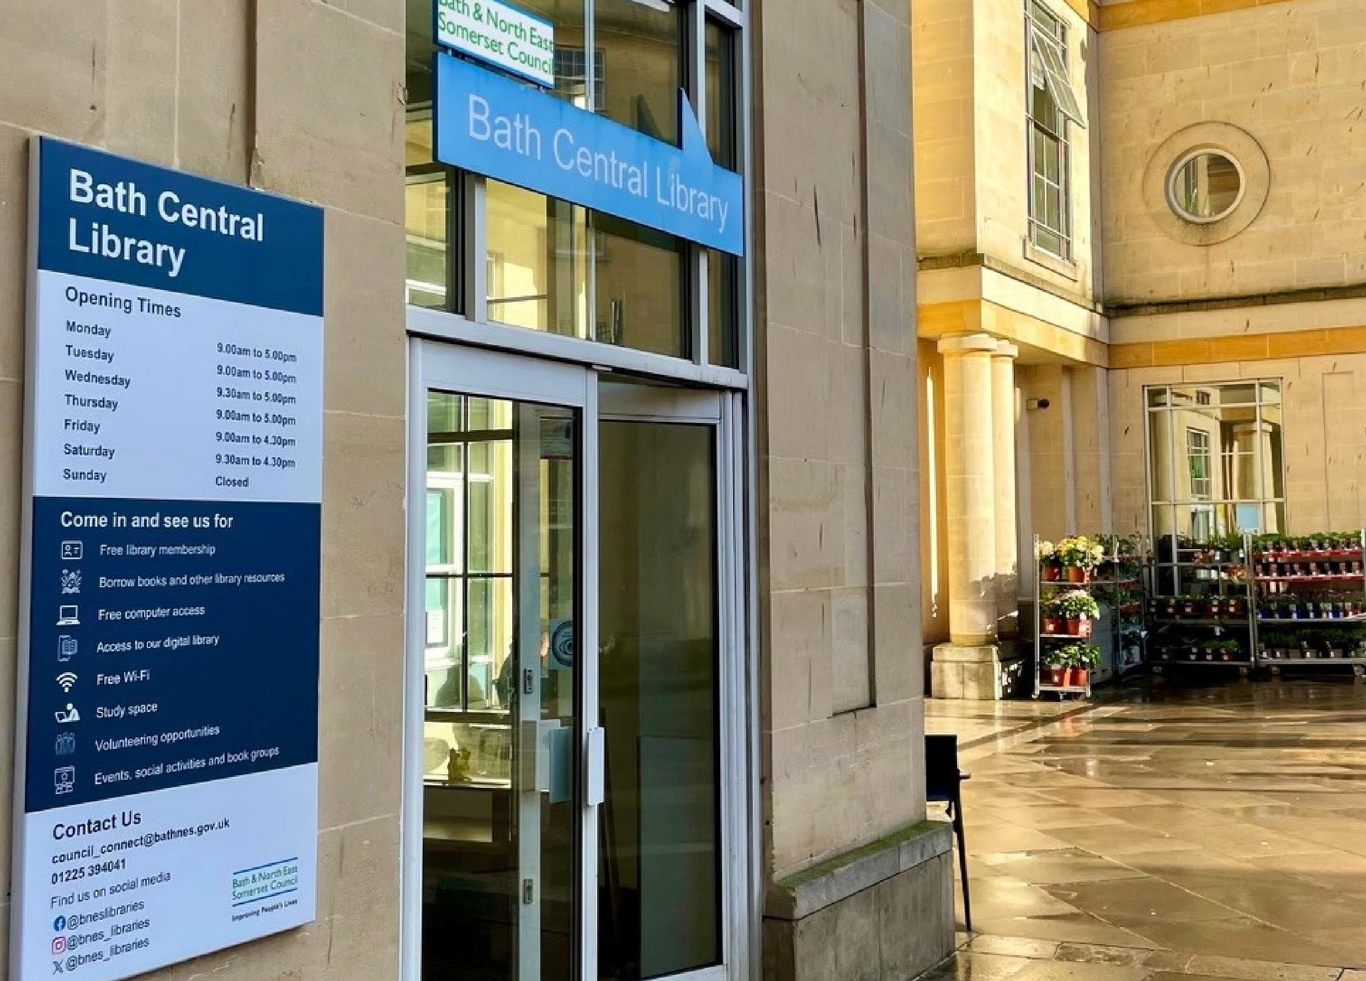

Bath Central Library

June 2026
Picture guide

Bath & North East
Somerset Council

Libraries

I am going to Bath Central Library

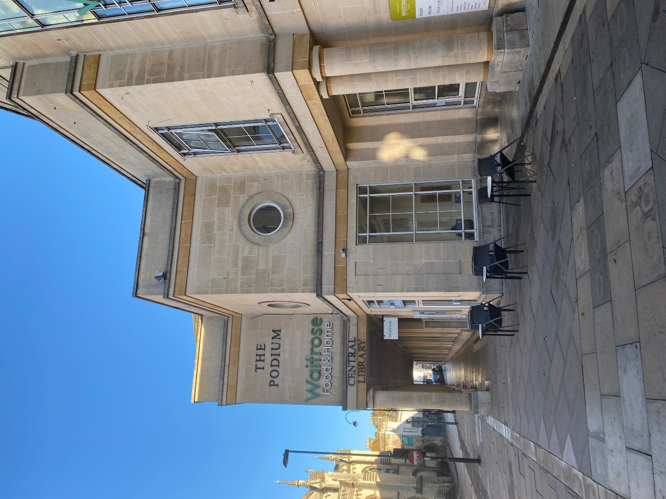

Video guides 4
Before I go to the library 5
About the library 7
How I become a member of the library 10
When I visit the library 12
Accessing more information 19

These productions were supported using public funding by Arts Council England. B&NES Libraries thank Libraries Connected and Arts Council England for their generous support.
Watch an introductory tour

Video guides
Watch these videos on YouTube and select the CC button to turn on Closed Captions. Follow along using the transcript.

https://www.youtube.com/watch?v=zeVI81ekNjU&list=PL9JE6hqzoLeWunlAIkteZ0YS_Qsu5Sj_X&pp=iAQB
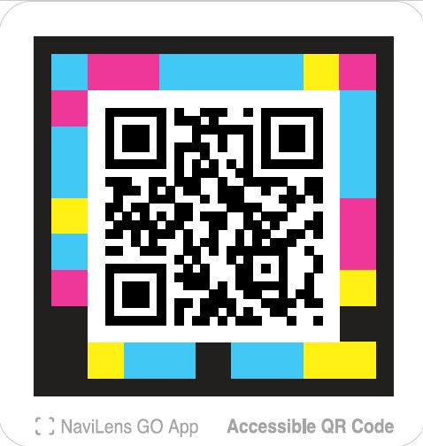


Learn how to
find us and what
services and
facilities are
available when
you arrive.

Before I go to the library

If I am nervous about going, I can talk to someone and ask questions first.
I can call 01225 477000 and ask for Library services or use the Sign Video relay service for British Sign Language users.

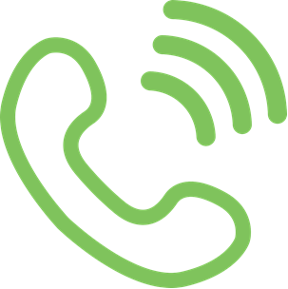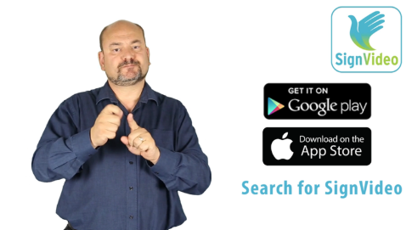

When I am at the library if I am a BSL user, I can ask about Sign Video Remote Interpreting (VRI) service which can be used by Deaf and hearing users calling together on-site. Staff will be able to help me if the service is available in their location.

I can ask for a tour of the library.

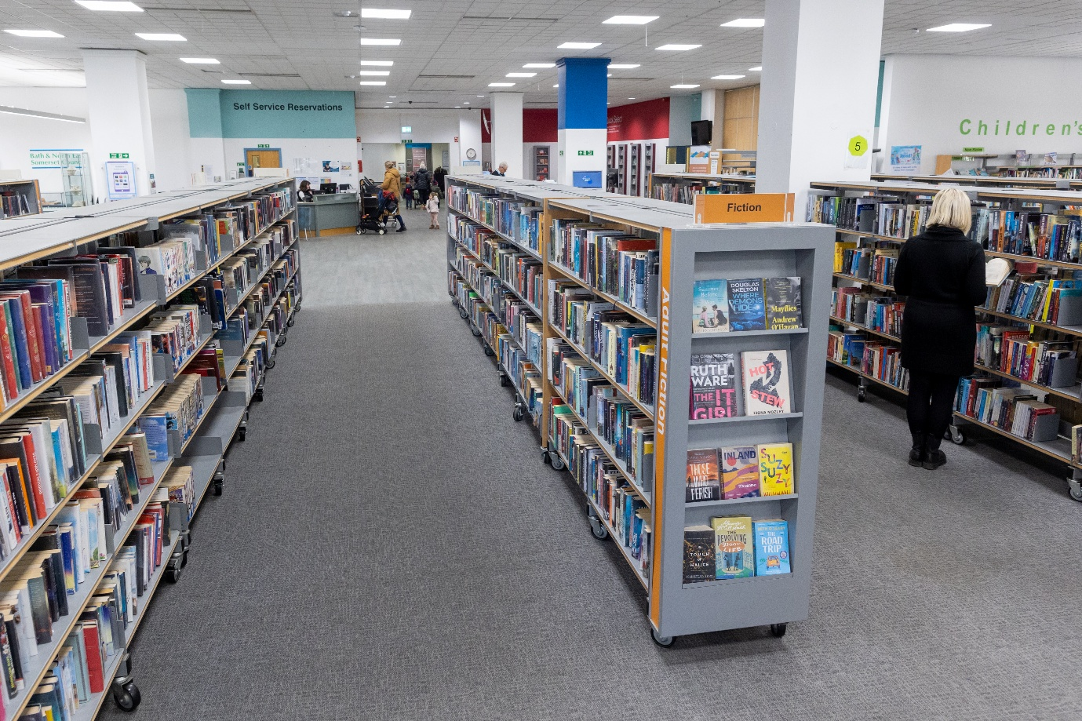

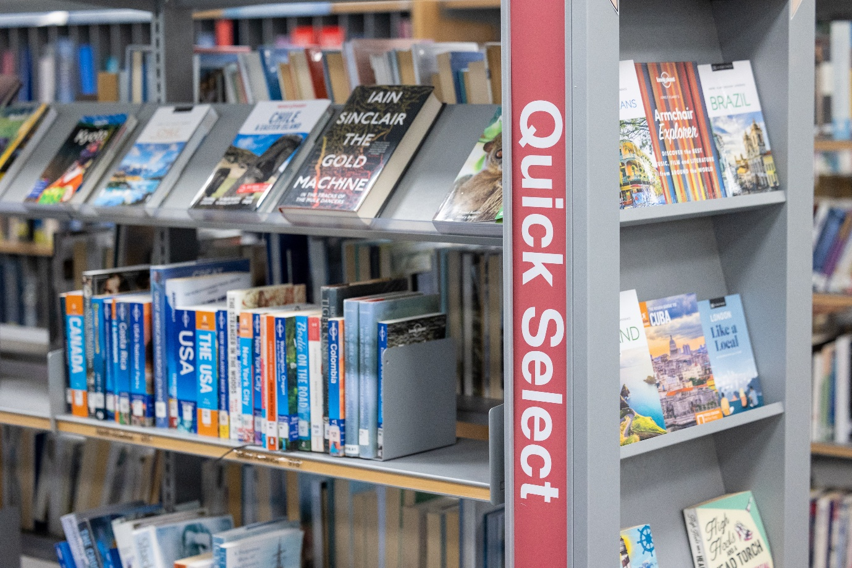

About the library

There are people who work at the library who I can talk to. They wear lanyards to show they work for the Council.

  - 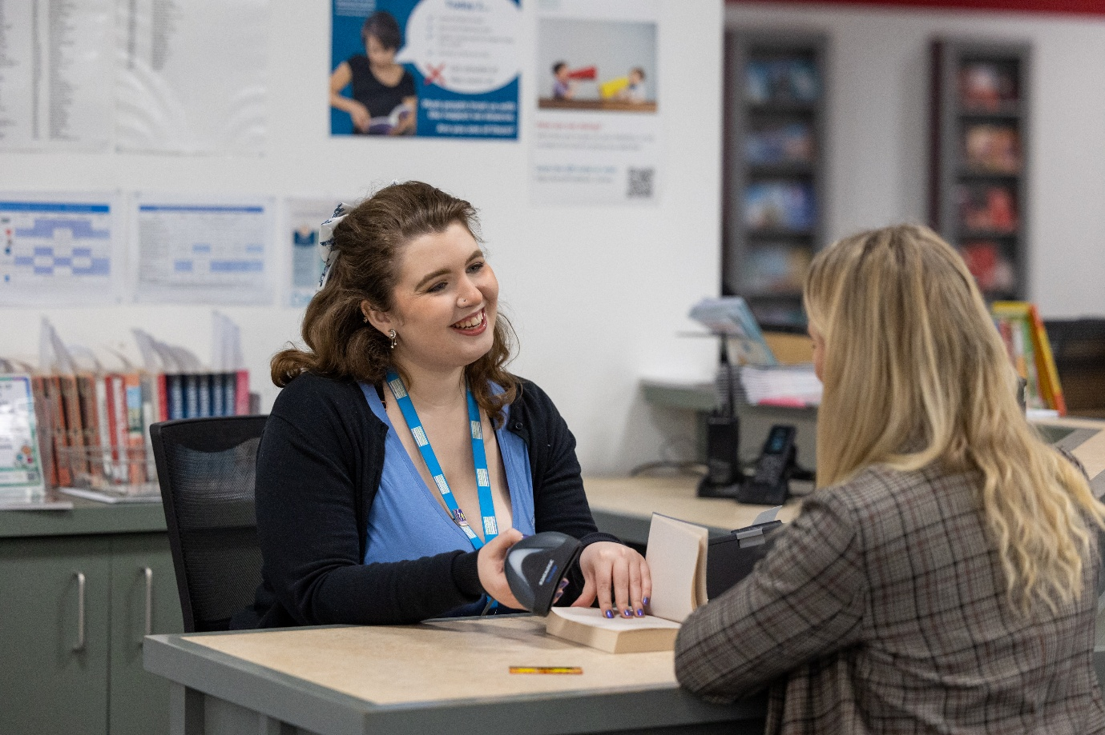

The library is usually a quiet place where people talk quietly, relax, and read books.
Sometimes it might be noisy and if it is I can talk to a member of staff who might be able to show me a quieter place in the library.

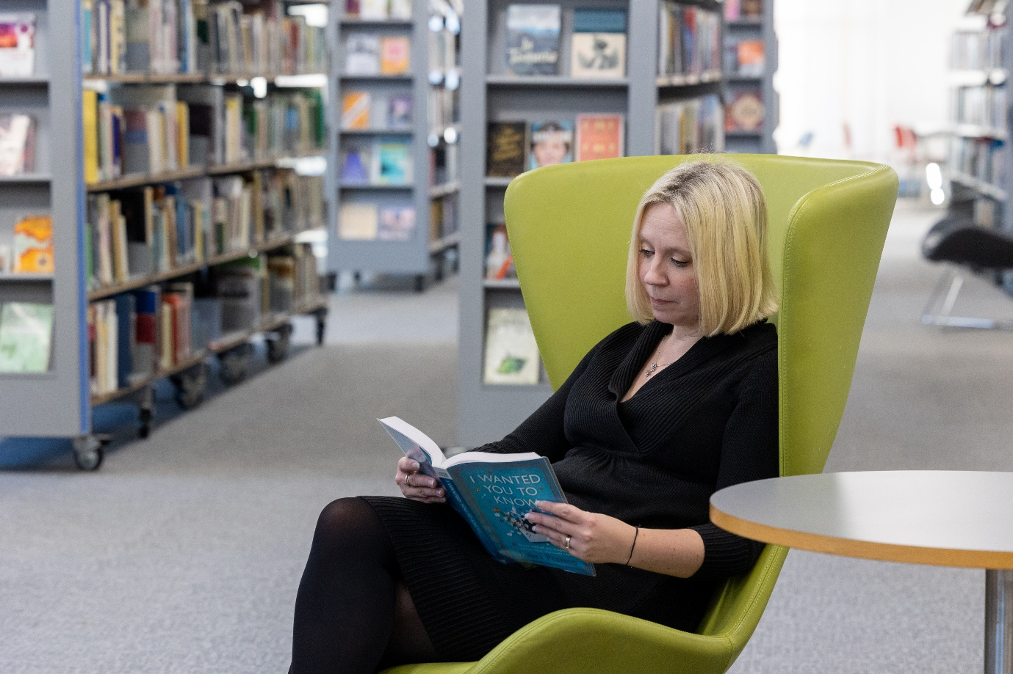

How I become a member of the library

When I get to the library, there will be a welcome desk.
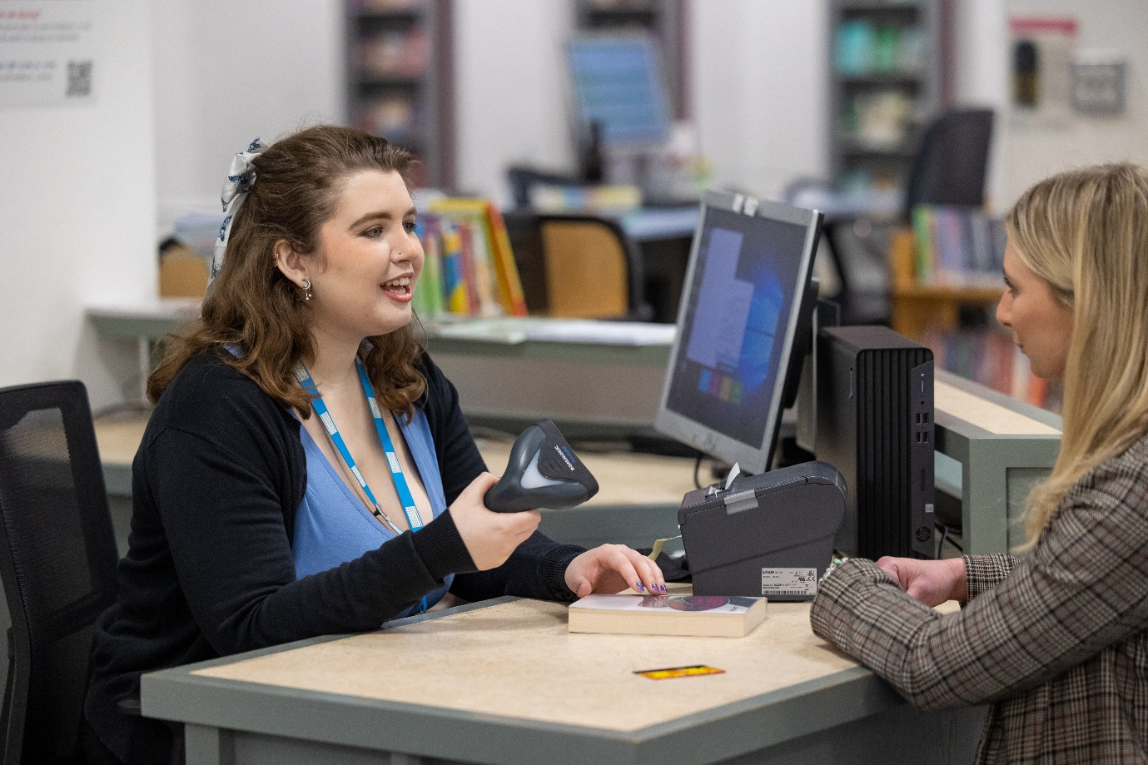

I will talk to someone who works there to become a member of the library.
To join, I will tell them my name, address, date of birth, telephone number and email address and say whether I am happy to be contacted with library service information by email. This might be about changes to opening times, events or surveys.
I will show identification that includes my name and home address. Adults can do this on behalf of children.
Once I have joined the library, I will be given a library card.

When I visit the library

In the library there will be shelves of books and DVDs.
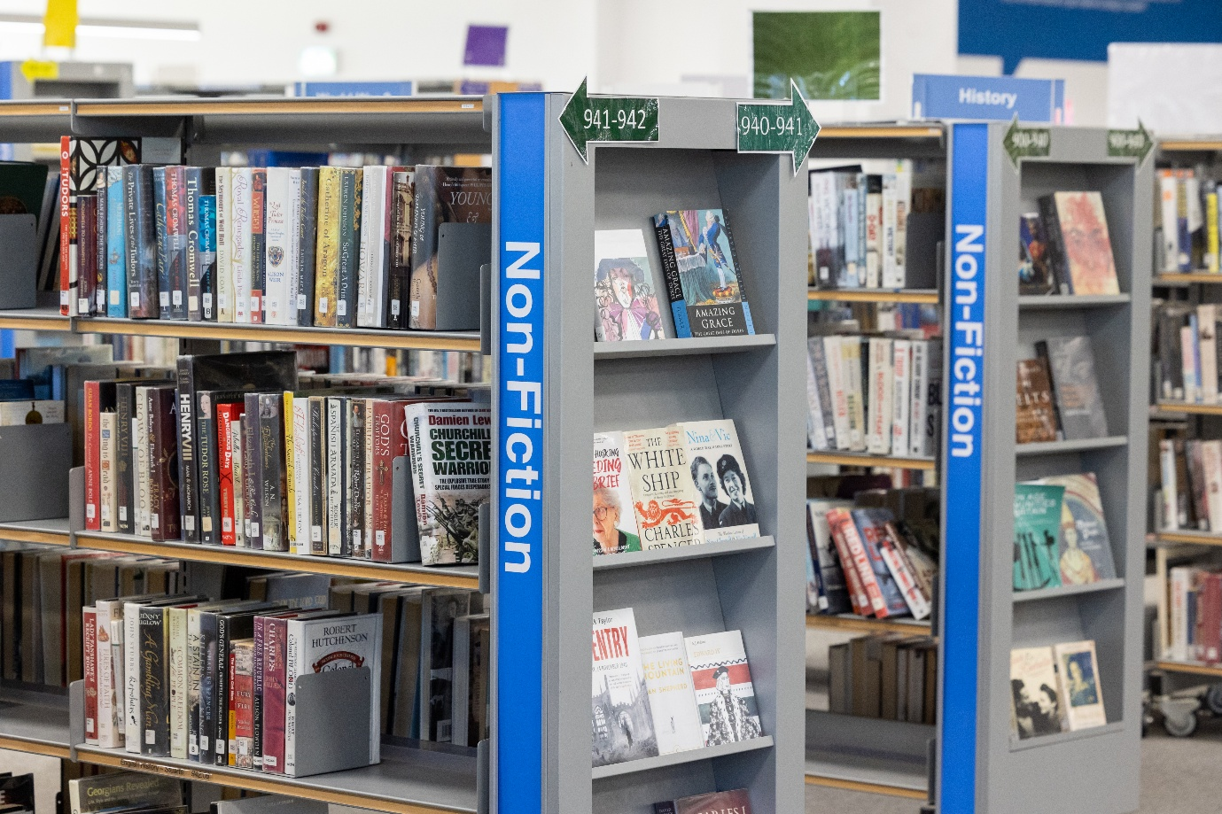
I can sit in a chair to read a book and I can borrow a book or DVD and take it home with me.

If I want to borrow a book, I can talk to a member of library staff or use a self-service kiosk.
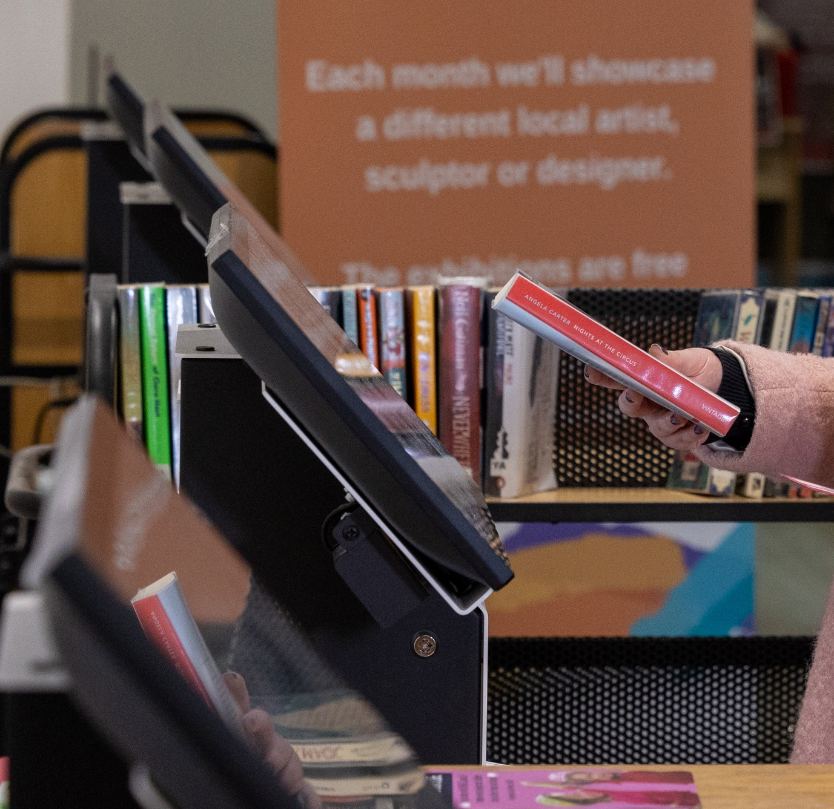
The staff can show me how to borrow the book or DVD and tell me when I need to bring it back to the library.

I can speak to staff about some of the available resources to borrow like Story Sacks or Bag Books which make storytelling fun and interactive. There is an Accessible Library Resources Shelf.
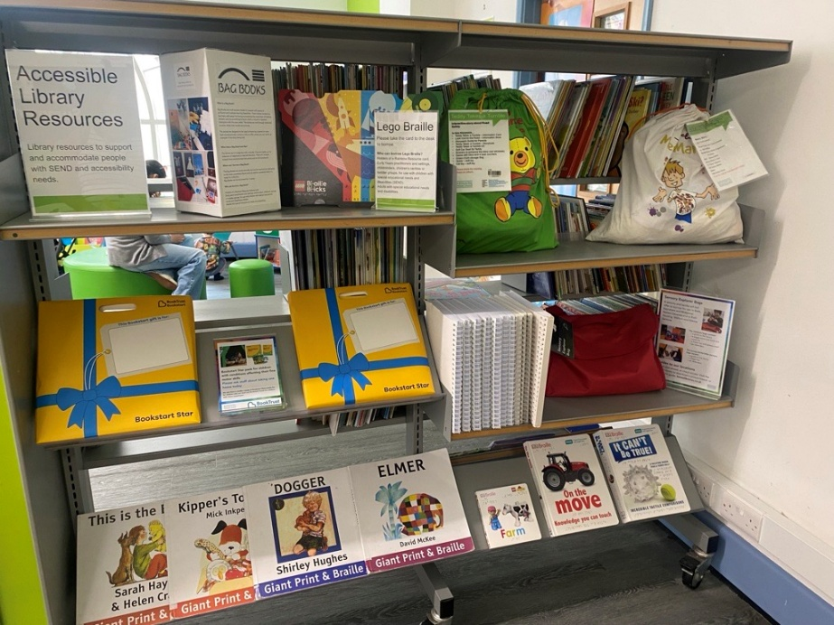
I can also ask about Book Trust material which can be gifted to young children with additional needs.

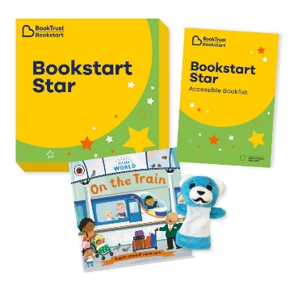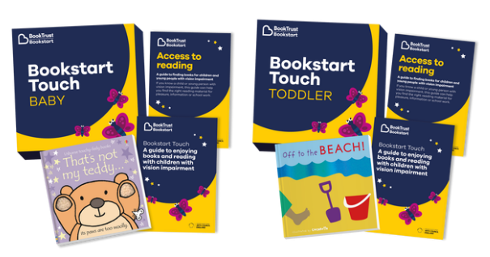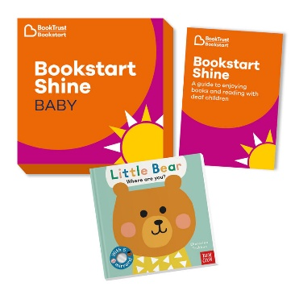

I can use my library card to log in a computer for two hours or use a free visitor pass for half an hour. I will pay to print.
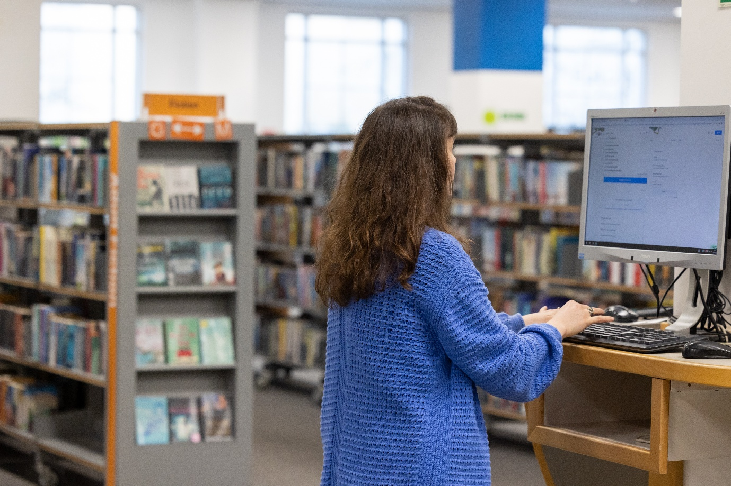
There is an exhibition room for events and displays.
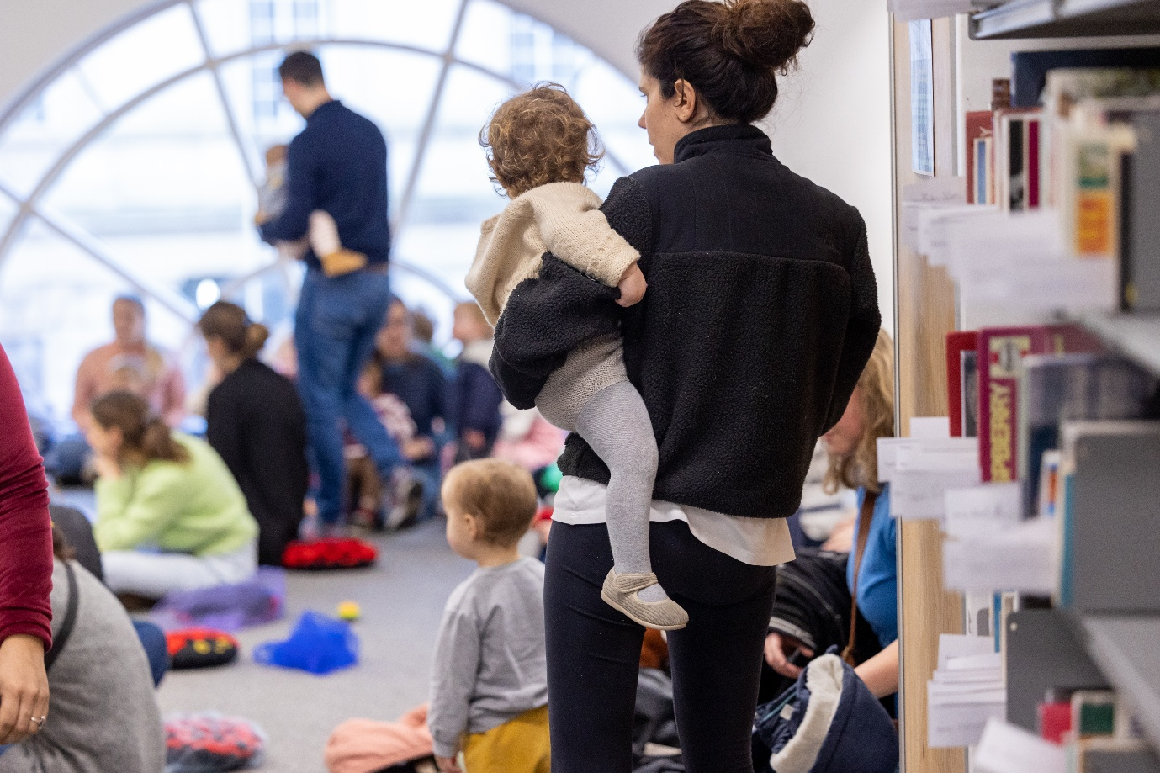
There is a study area I can sit in.
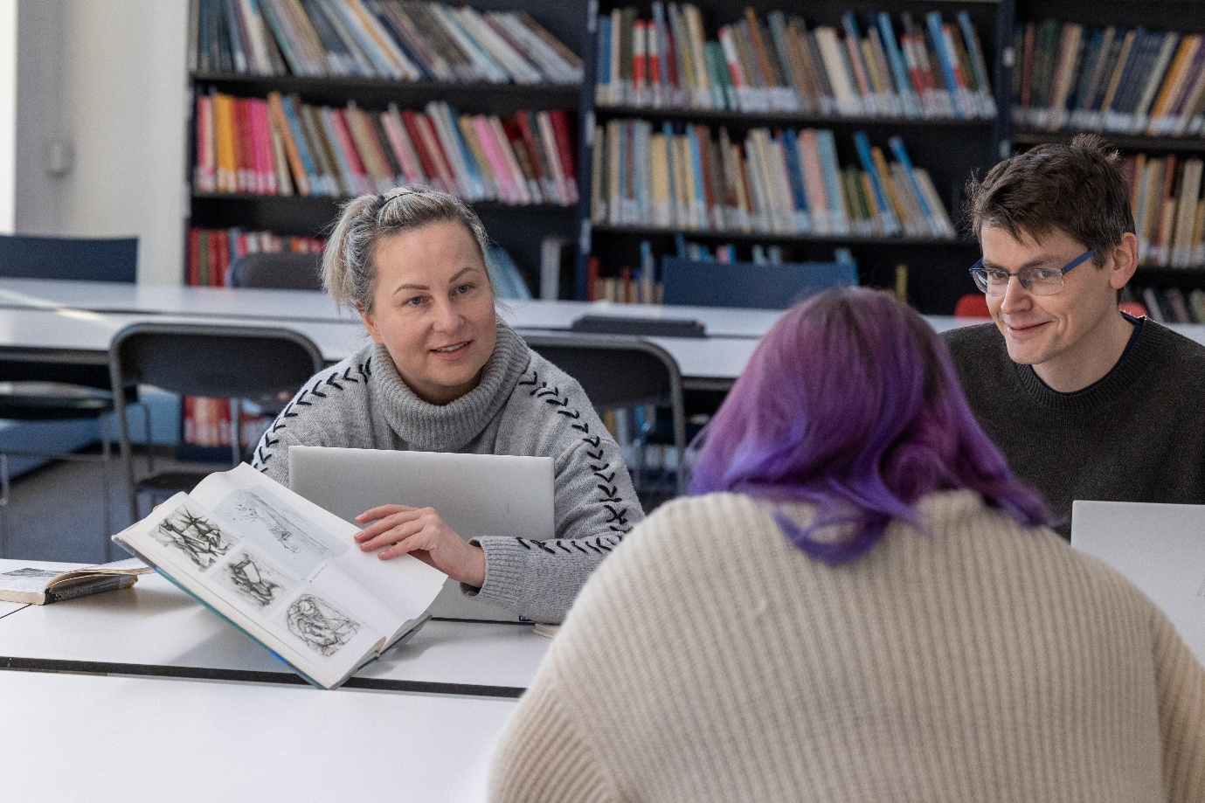

I can borrow a Sensory Explorer Bag to use in the library. It has ear defenders, a guide and other things to help my visit.

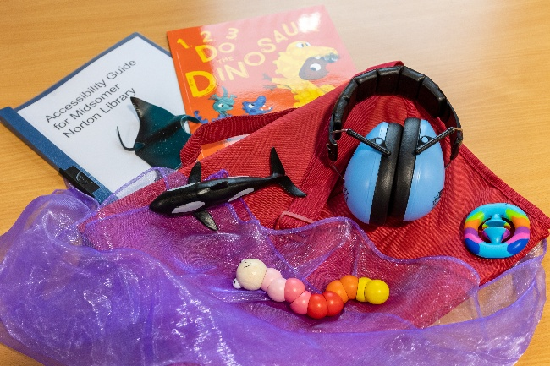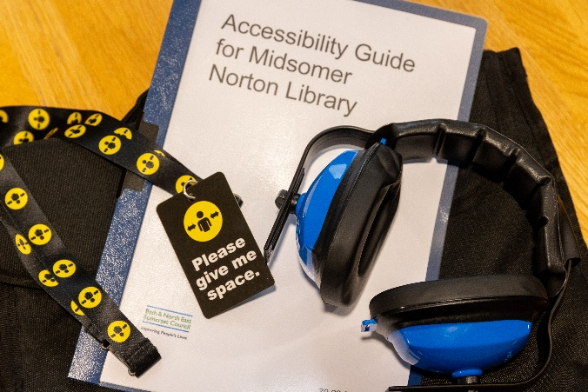

The library will also have a sensory room I can book or ask about drop-in availability.
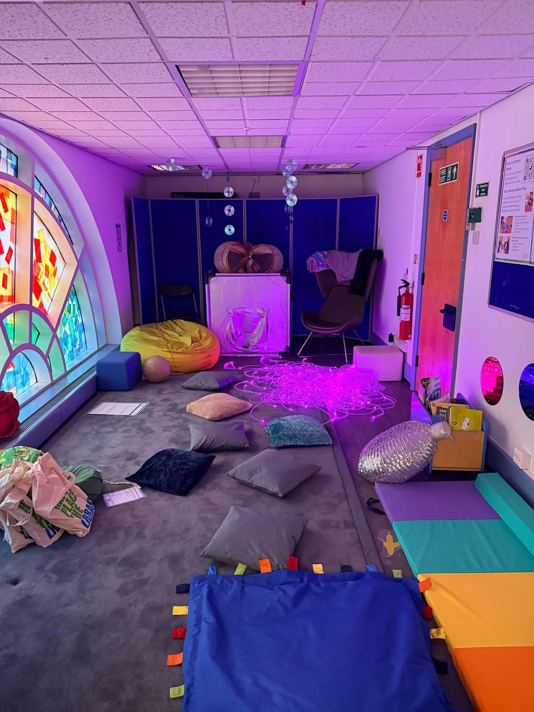

When I have finished, I will leave the library.

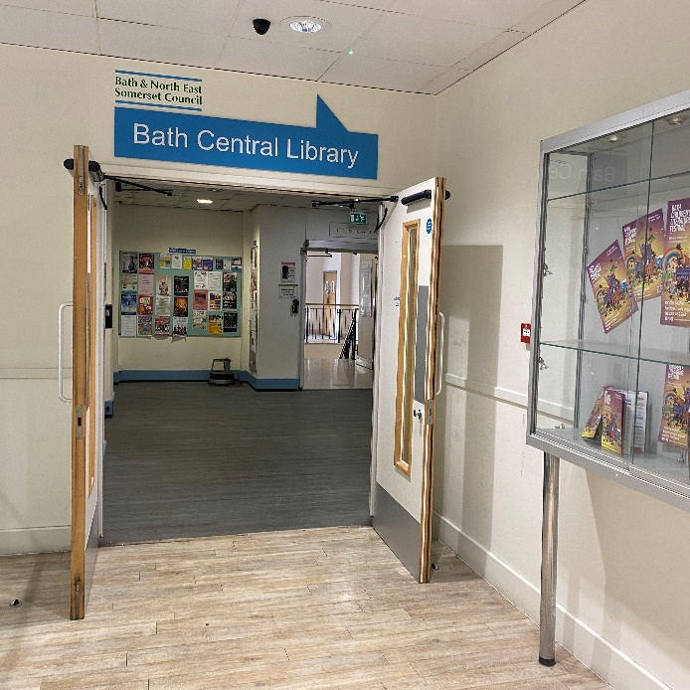

Accessing more information

I can visit the Virtual Library online to find out about events and special resources available at the library and online on the Access For All page: https://baneslibraries.co.uk/about-us/access-for-all/.

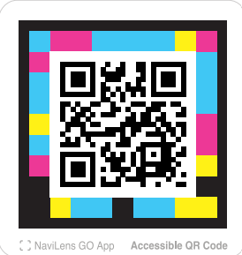

Follow this QR code to visit the Virtual Library.

