Tear away tiger Instructions:
What you will need:
- Plain white paper | - Googly eyes
- Scissors | - Colouring pens and pencils
- Glue Stick  - Coloured card | - Tissue paper  - Tiger templates

Instructions:
- Start by tearing up lots of strips of black and orange paper. This can be a mix of coloured paper and tissue paper.
- Stick the long pieces of paper across your white piece of paper in the portrait position.
- Whilst your main piece is drying start cutting out your tiger’s nose and ears using the templates available or create your own!
- Stick down your tiger pieces wherever you’d like to create a face using a glue stick.
- Add your googly eyes to your tiger.
- Use a black pen to add whiskers to your tiger and it will be complete!

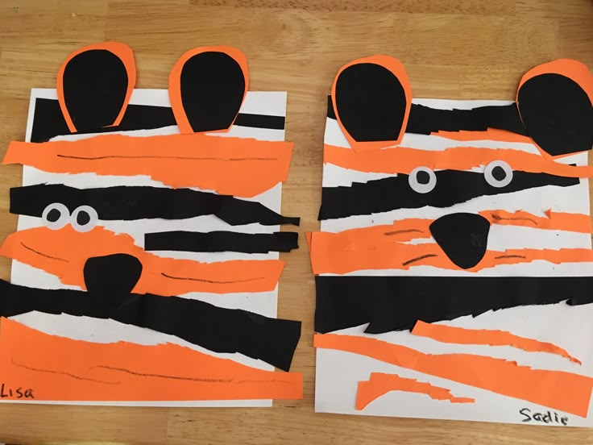

Tiger Nose

Tiger Ears

