Superhero Mask Instructions:
What you will need:
- Card | - Sellotape
- Scissors | - Colouring pens and pencils
- Mask template  - Stickers | - String  - Holepunch

Instructions:
- Pick a colour for your mask from the paper available.
- Use the template available to cut around your paper.
- One you have cute out the main shape have a grown up help you cut out the eye holes. A good tip is to mark with an x where your eyes are with a pen or pencil and cut an oval around them.
- Use a hole punch to create holes on either side of the mask near where the eye holes are.
- Thread some string through each side. It is helpful to measure the string around the persons head then cut it in half with enough to comfortably tie it around your head.
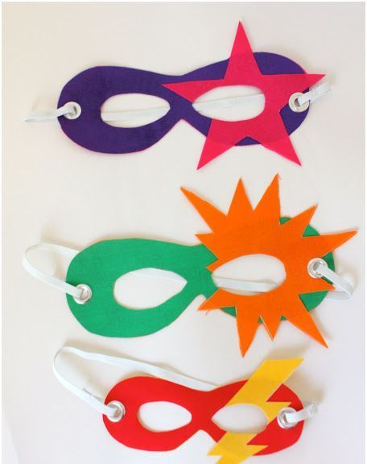
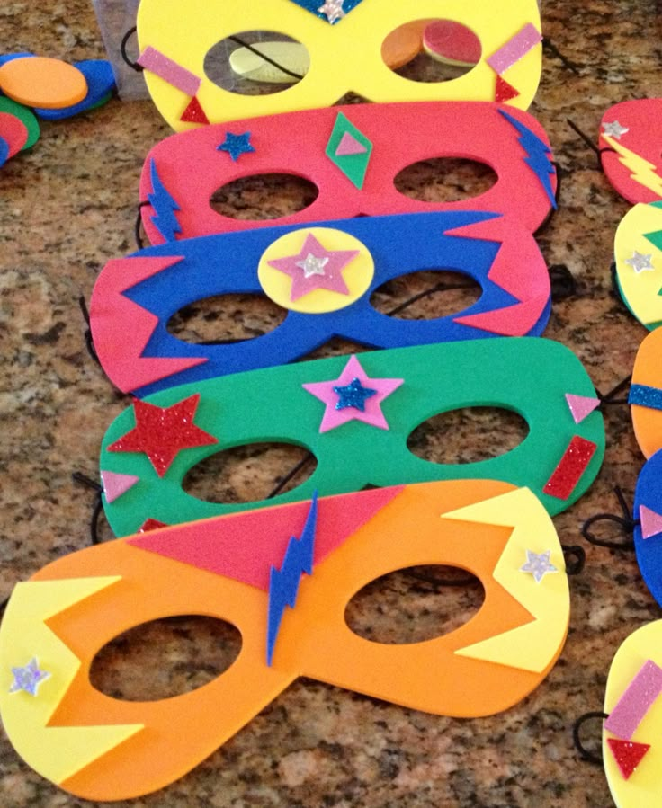
- Add details to your mask to make it reflect your superhero! Use stickers and colouring pens to decorate.

