Paper Plate Dinos Instructions:
What you will need:
- Paper Plate | - Googly eyes
- Scissors | - Colouring pens and pencils
- Glue Stick  - Stickers | - Dinosaur part templates  - Coloured paper

Instructions:
- Cut your paper plate in half. You can fold it in half to help guide you.
- Colour in your plate as your dino’s body. Add any stickers to it you’d like.
- Cut out the dinosaur parts using the templates provided or use your imagination and create whatever you like!
- Colour these templates in whatever colour you’d like.
- Stick the dinosaur parts onto your paper plate using the glue stick.
- Add a googly eye onto your dinosaur’s head and you are all done.
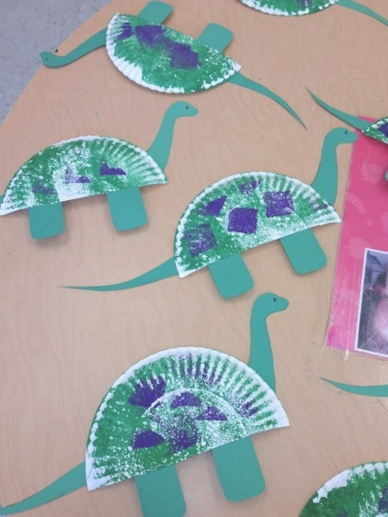
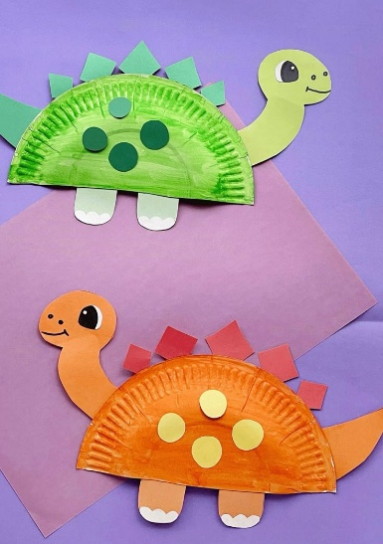

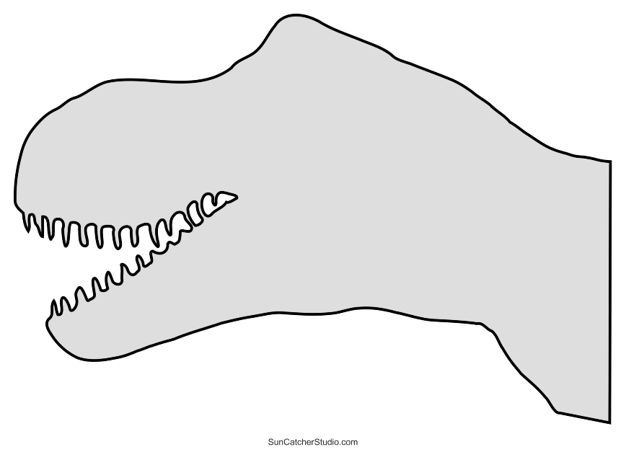
Templates

Dino tails
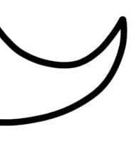

Dino Feet

