Spaceship Instructions:
What you will need:
- Coloured Card | - Sellotape
- Scissors | - Colouring pens and pencils
- Lolly sticks  - Stickers | - Glue sticks

Instructions:
- Use the alien space ship templates to cut out your space ship in colours of your choice.
- Cut out different shapes to add décor to your space ship and legs for it.
- Add your alien creature, either by drawing your alien on or creating it with colourered paper.
- Attach a lollystick to the back of your space ship using sellotape.
- Your space ship is complete!
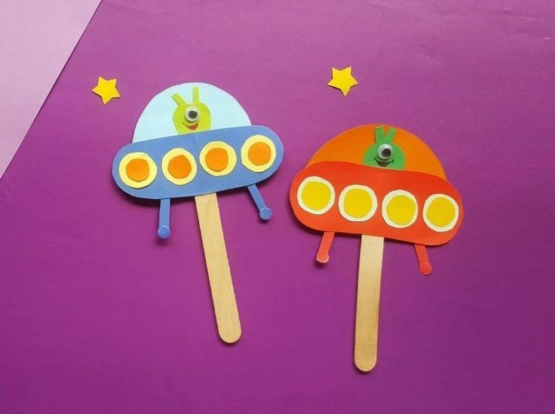

Space Ships

Alien Template

