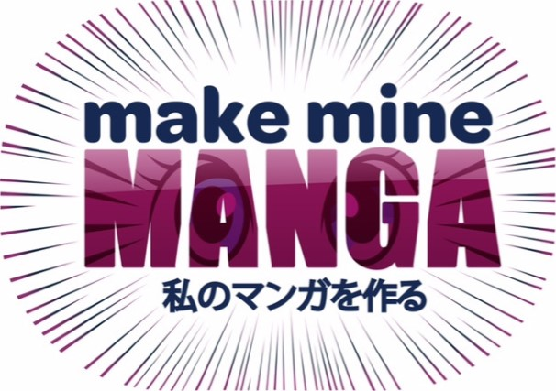
Manga character competition
Have you been inspired by the Make Mine Manga exhibition and activities? To celebrate the Make Mine Manga Exhibition coming to Bath, we want you to create a Manga Character and tell us about them.

Could yours be the winning drawing, as judged by Japanese Manga artist and illustrator Chie Kutsuwada?
Prizes include weekend passes to the Lakes International Comic Art Festival*, a signed copy of 10 Step Drawing: Manga by Chie Kutsuwada and goodies from American Dream Comics.

How to enter Use the page on the reverse of this form for your design and drop it off at any of our libraries in Keynsham, Midsomer Norton, Bath Central or on the Mobile Library. Deadline for entries is Saturday 21 June at 12pm.
Name.....................
B&NES library card number......................................................................
Category entering: 15 and under 16+
Email address.
Describe your
character............................................................................................................................................................................................................................................................................................................................................................

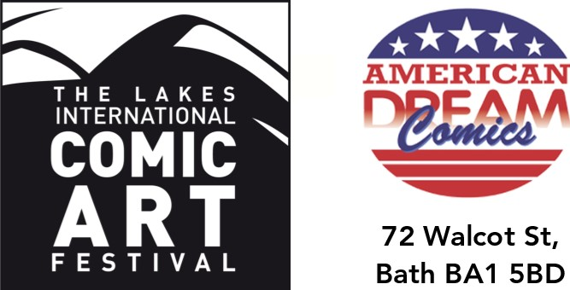
Kindly sponsored by
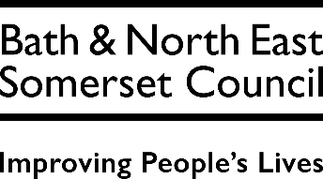

*Please be aware, tickets for under 12s Little LICAF need to be purchased separately.
Manga character competition entry

