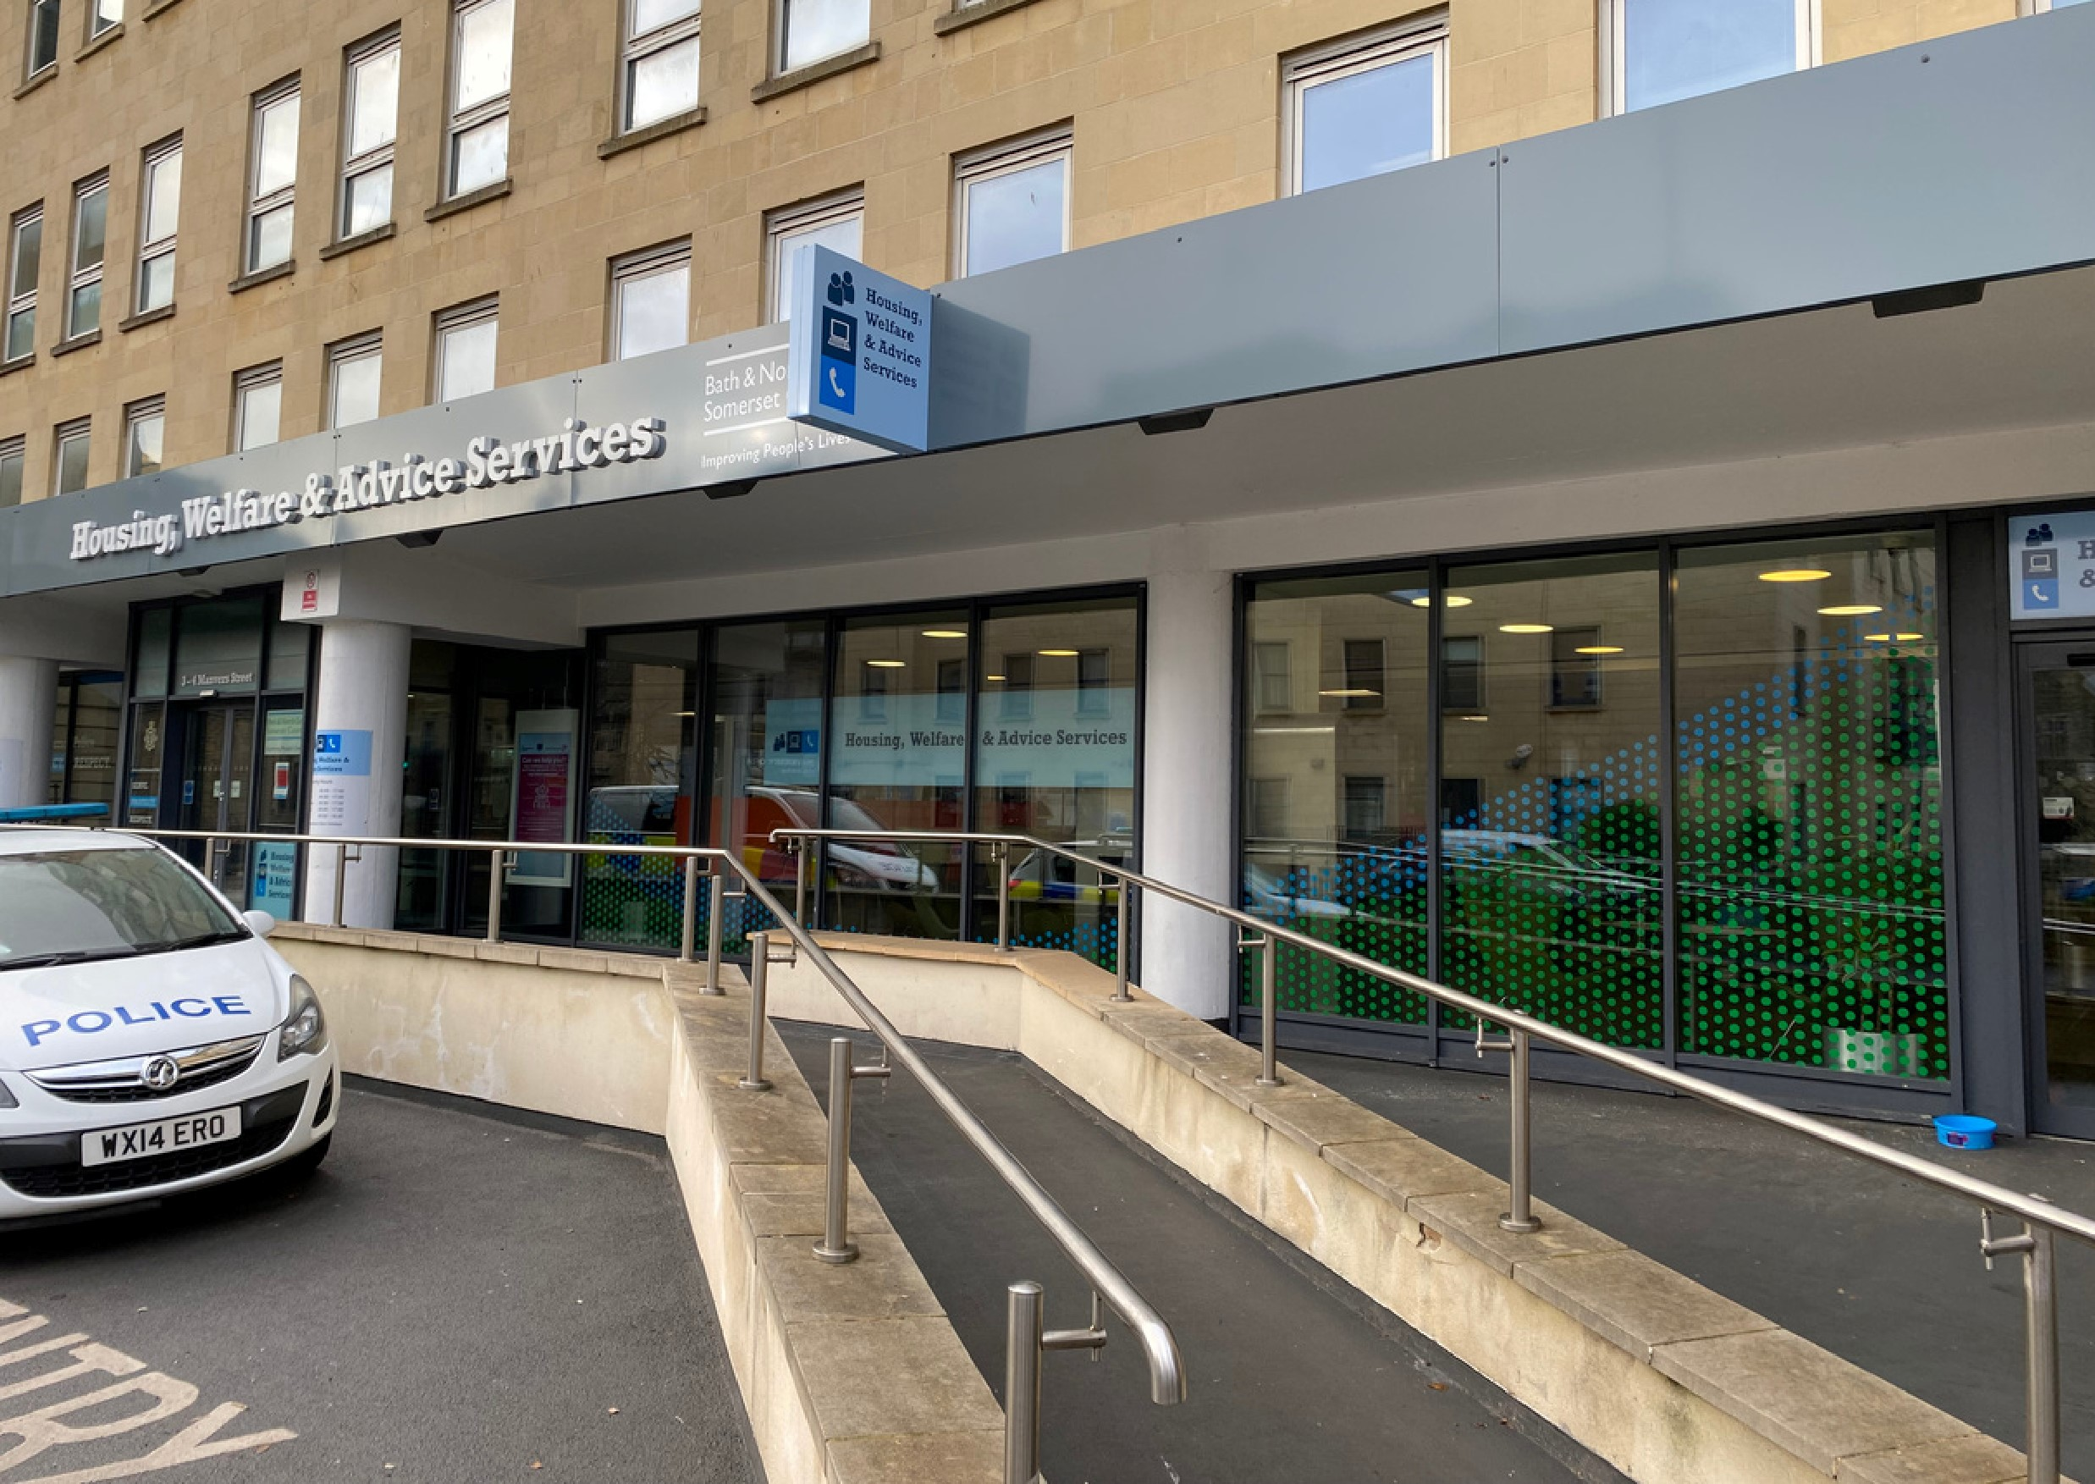

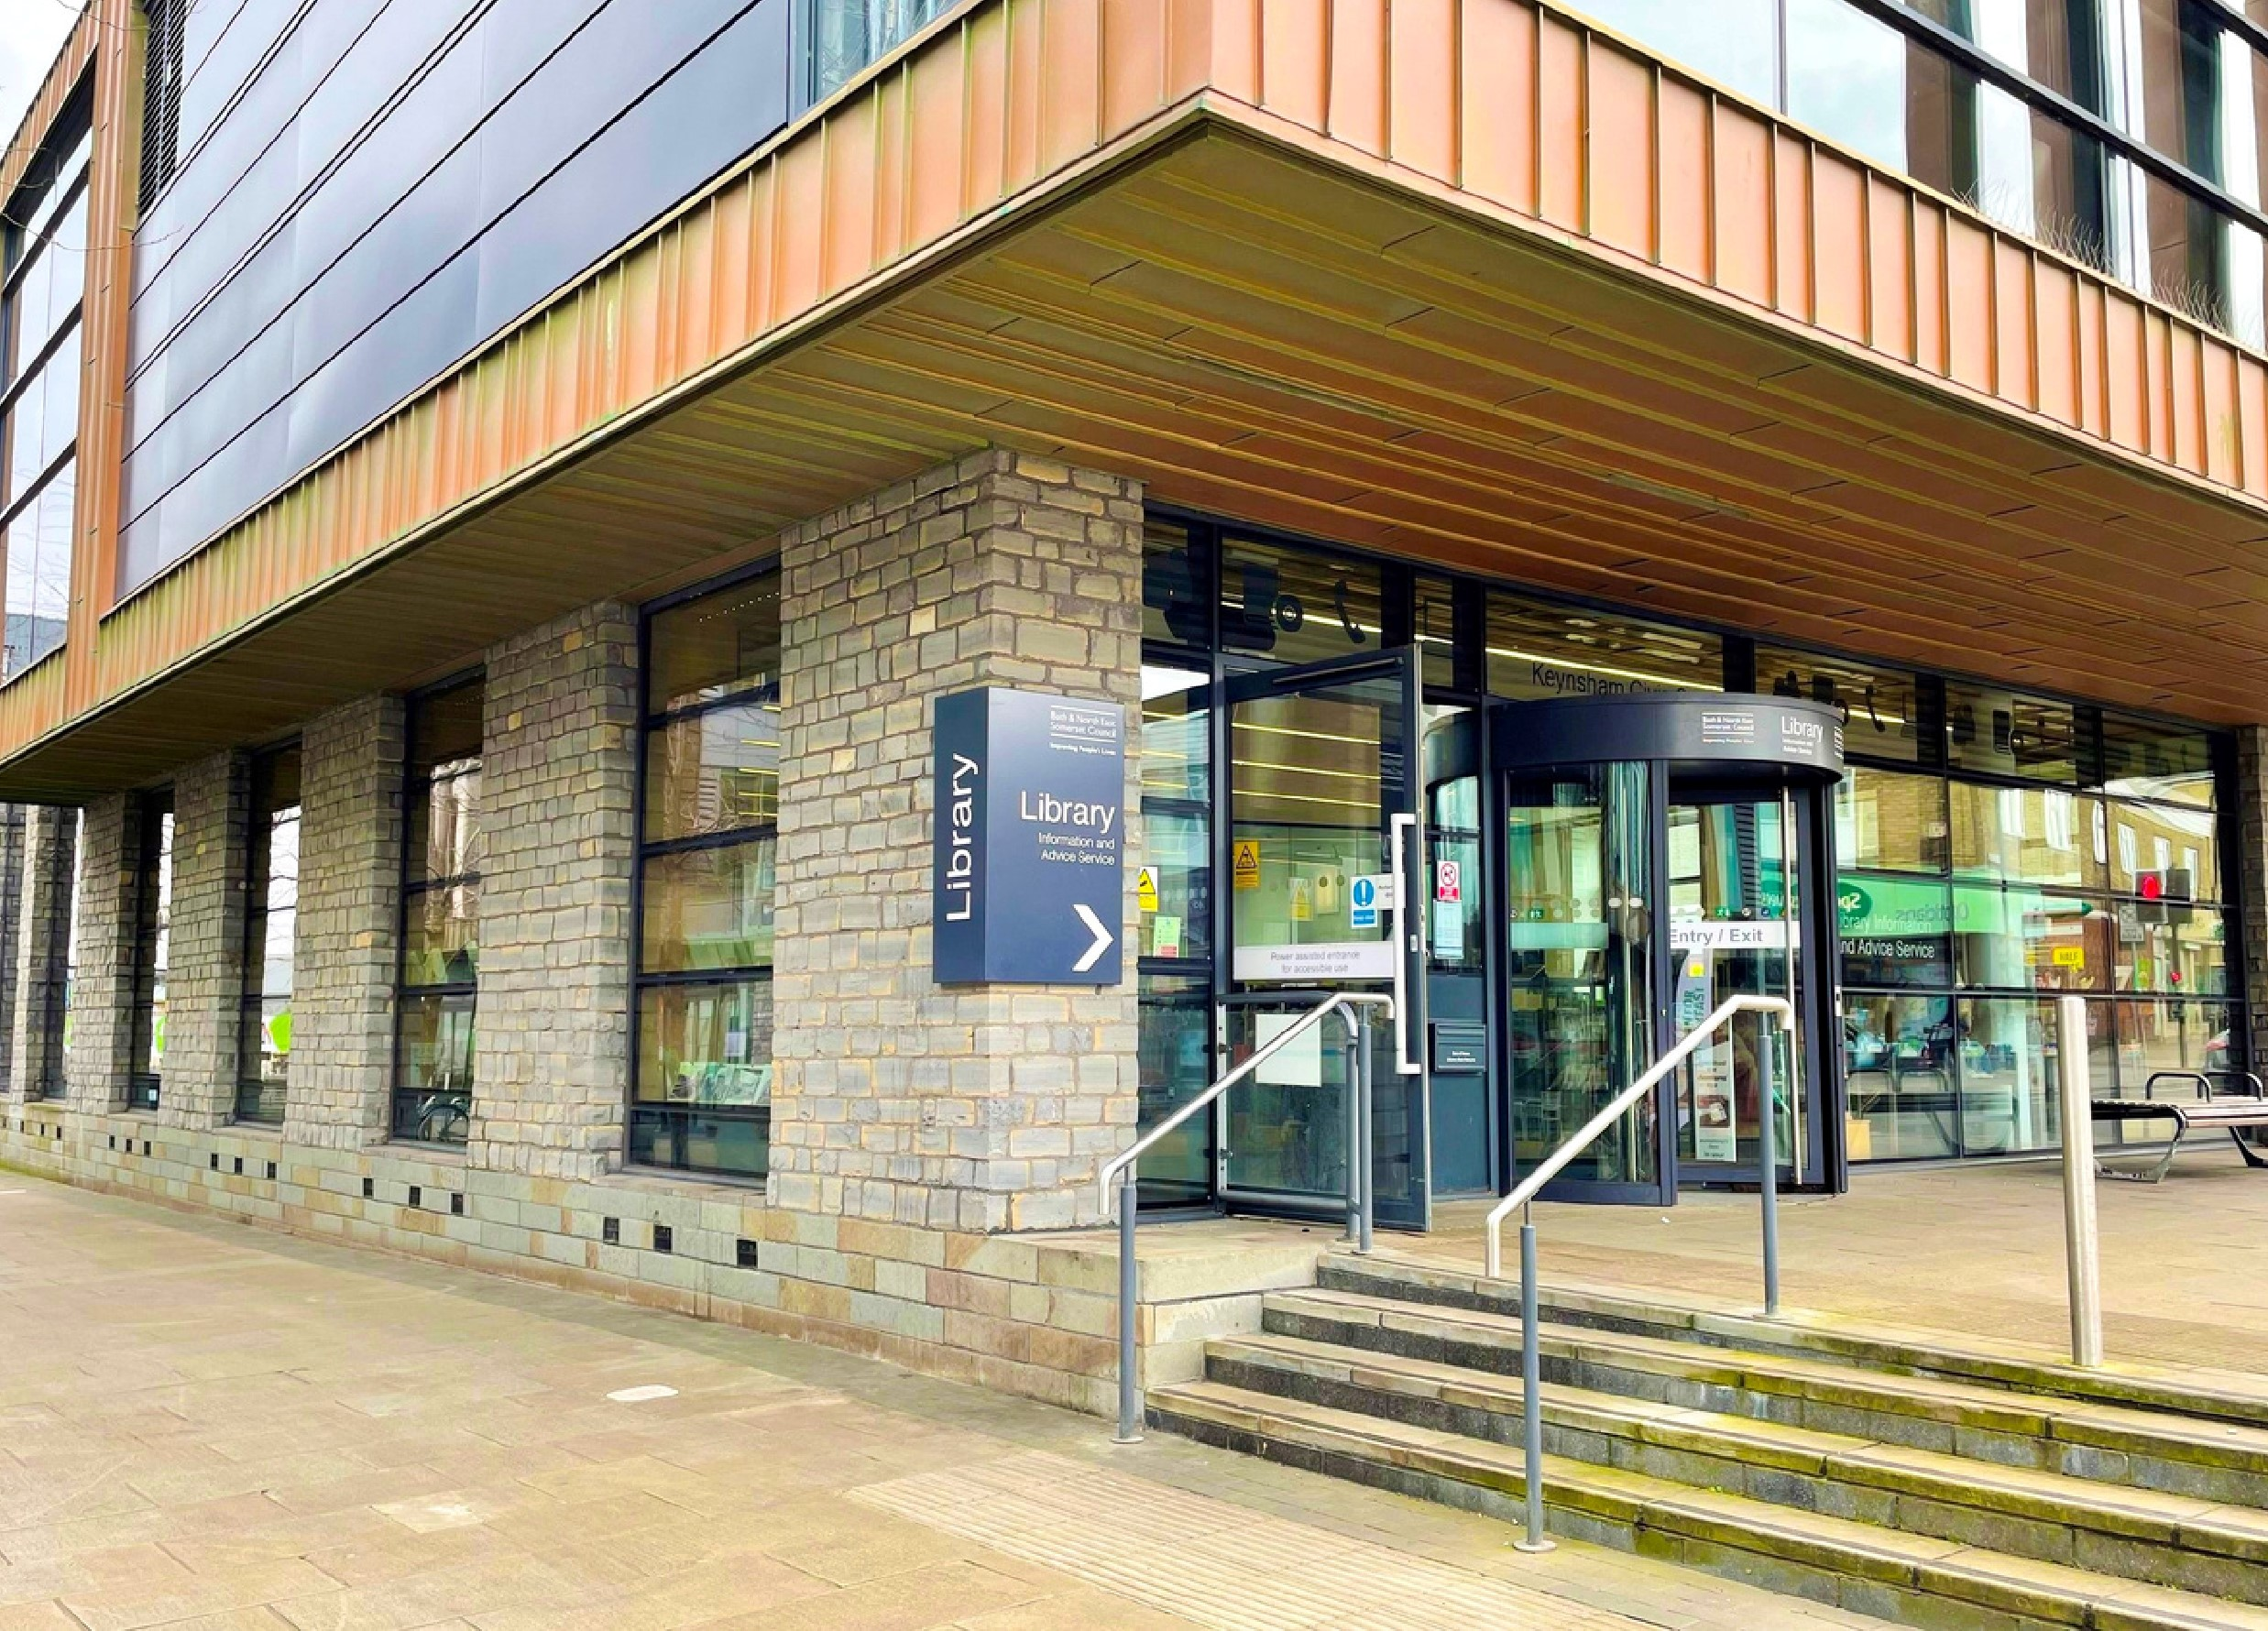
Keynsham Library and
Information and Advice
Services
Large Print Access Guide
November 2024
 Access guide for Keynsham Library and Information and Advice Services

Summary
This guide outlines basic information about arriving and support and facilities when you are at Keynsham Library and Information and Advice Services.
Assistance and Guide Dogs are welcome.
Please ask staff for help or if you have any questions.

 Public Transport

- Local buses serving Bath, Bristol and the local area operate from surrounding roads around 0.2 miles away.
- The nearest train station is Keynsham, 0.5 miles away.
- There is a loading bay in front of the building which can be used to drop passengers off.
- If travelling by car, there is a car park at the Civic Centre which has nine disabled spaces.

 Main entrance

- Access is at street level, via steps or ramped paving by the Keynsham clock tower.
- The main automatic door is 124cm wide and opens towards you. There is a push button to activate it.
- There is also a revolving door.

Exit

- Customers leave via the Community Space exit which is to your right on entry after the Children’s Library.
- The door from the library is always open during operational hours. To exit the building, use the second set of automatic double doors which open outwards when activated by a hand wave or similar motion.
- This is used as an exit only door while the library is operational but is the entry and exit when being used for access to the Community Space outside of library hours.
- Contact details for enquiries about the accessibility of the Community Space can be found on the Council website.

Tactile map

A tactile map can be found by the main stairs on the ground floor and in the Community Space Foyer on the first floor.

 Main library enquiries desk

As you enter the library, the main enquiry desk will be on your left.
- The desk is 101cm high and staff can provide a chair on request.
- There is an induction loop system in use.
- Staff wear black and white uniform and a lanyard.
- There is a smaller information desk nearer to the entrance which is occasionally staffed.

Information and advice enquiries desk

If you require assistance with council services, please visit the information and advice enquiries desk.
- This is located to the right of the ground floor after the Self-Service kiosks.
- There is an induction loop system in use.

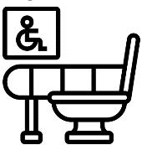 Accessible Toilets

There are several accessible toilets.

There is step free access to a Changing Places accessible toilet on the ground floor beyond Pam’s Pantry. It has an indicator bolt with handle, emergency cord, support rails and a lever tap.
- There is a second accessible toilet on the ground floor next to the lift and exit. It has an indicator bolt with handle, emergency cord, support rails and a lever tap.
- There is an accessible toilet on the upper floor in the foyer of the Community Space. It has an indicator bolt with handle, emergency cord, support rails and a lever tap.

 Standard Toilet

There is an accessible toilet on the ground floor which is unisex and available for all to use. There is step free access.

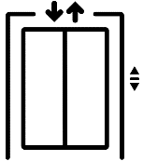 Lift

The lift is in the Community Space and exit foyer. The first floor is accessible via this lift.
- Internally the lift has buttons with a medium colour contrast to the surroundings, controls at a recommended height range (between 90cm - 110cm), an audible announcer and a visual floor indicator.
- The lift opens to the Community Space foyer on the first floor. However, there is a pull to open door which opens to the main first floor library space. Please ask staff for assistance if you require help to access the first floor using this lift and door.

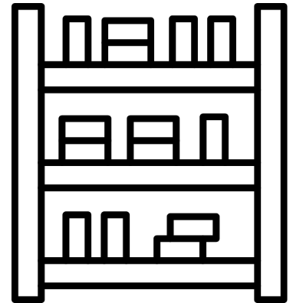Library and information service floor

- There is step-free access throughout the ground floor space.
- Assistance may be required to access the first floor from the Community Space Foyer as there is a pull door from the foyer to the main space.
- The ground and first floors are very open, and the library has high ceilings but there is very little background noise unless events are taking place.
- Check our events timetable if you wish to plan around this but please note that some events like school visits will not be listed on the public event timetable.
- There is seating throughout.
- The area has a hard floor and upstairs is hardwood leading to carpet.
- On the ground floor there is a large section of mosaic floor lit by LED lights which is covered by glass flooring. This leads onto a hard wooden floor separated by a flush metal divider.
- There is strip lighting throughout and as many walls are glass, this is a light space benefiting from natural light. There is frosting on some of these panels to limit glare caused by sunlight.
- The upper section of the staircase leading to the first floor has open sections of plastic panelling which lets natural light in between the top five stairs.
- Each stair has a dark strip to help customers see the edge of each step.

Public network computer access, tablets and Hublets

Please ask staff if you need help with these resources.
- Currently Windows accessibility features are disabled due to Council restrictions on access to settings on public computers. We are working to resolve this.
- Hublets are tablets which are free to borrow and use in the library for 2 hours per day – it is possible to enlarge font.
- On the ground floor, there are two computers at the rear of the library on desks with a 76cm height.
- On the first floor, there is a double row of computers on tables and space for laptop use with a 76cm height. There is an additional single computer on a separate smaller table.

 Guides

As well as this large print guide, each location has an accessibility guide like a social story with simple information and pictures. Download from our website or ask staff for a copy.

 Sensory experiences

A sensory experience refers to the perception or reception of information through the five senses — sight, hearing, touch, taste, and smell as described in sections below.

Crowds

Our quieter times of the day are generally at the beginning and end, but this can change if we have events or school groups in. Please check our events timetable online.

Lighting

We advise use of our pods underneath the stairs on the ground floor for customers who appreciate lower lighting.

Noise and sound

- To access quieter areas, we recommend the first-floor area and the pod on the ground floor.
- Our toilets have hand driers which can be noisy.
- Regular fire alarm tests take place on Wednesday mornings.
- We have an evacuation chair in the staff area which can be used on stairs in the staff area of the building.
- In the event of a genuine fire alarm, staff will be on hand to assist and advice on procedure.

Temperature

- We are proud to be part of the Warm Spaces scheme, meaning we are a free, heated venue in which to spend time in the winter months.
- Our spaces, especially the Sensory Space can feel particularly warm.
- Please ask staff for drinking water if needed.

Smells

There is a café serving refreshments located on the ground floor of the library, so there may be sounds and smells associated with this when it is open.

Sensory Space

- We have a small Sensory Space which is open to all to use but we particularly welcome families and small groups of children and young adults with sensory needs.
- The room can be booked on Eventbrite. We offer a drop-in session between 3.30-4.30pm.
- If you or someone you are visiting with becomes dysregulated or you need a quieter space, staff may be able to make the room available to you on request.

 Sensory Explorer Bags

We provide borrowable Sensory Explorer Bags for children, young people and anyone else who would benefit.
- The bags can be borrowed from the main desk and are for use in the library.
- Explore the library using the fidget aids and ear defenders to improve the visit.

